**AWS assessment**

In each section we have given 5 questions u can write any of 3 from that 5 from each section. The time duration is 2 Hours. If possible, we can extend half an hour.

For each question after getting the output. Take a snapshot and copy it into Word document by giving the question number.

**A.Category: Easy (5 questions)**

1.AWS CLI Basics:

a. Create an S3 bucket using the AWS CLI.

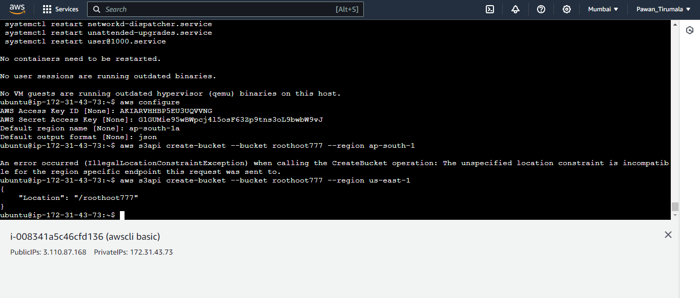

b. List the contents of the newly created S3 bucket using the AWS CLI.

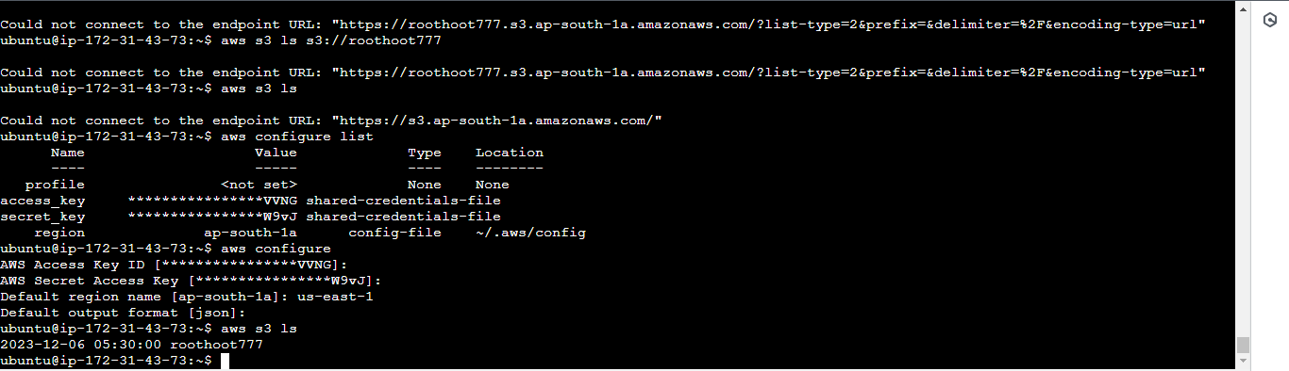



2.EC2 Instance Creation

a. Launch an EC2 instance in a specific AWS region and availability zone using the AWS Management Console.

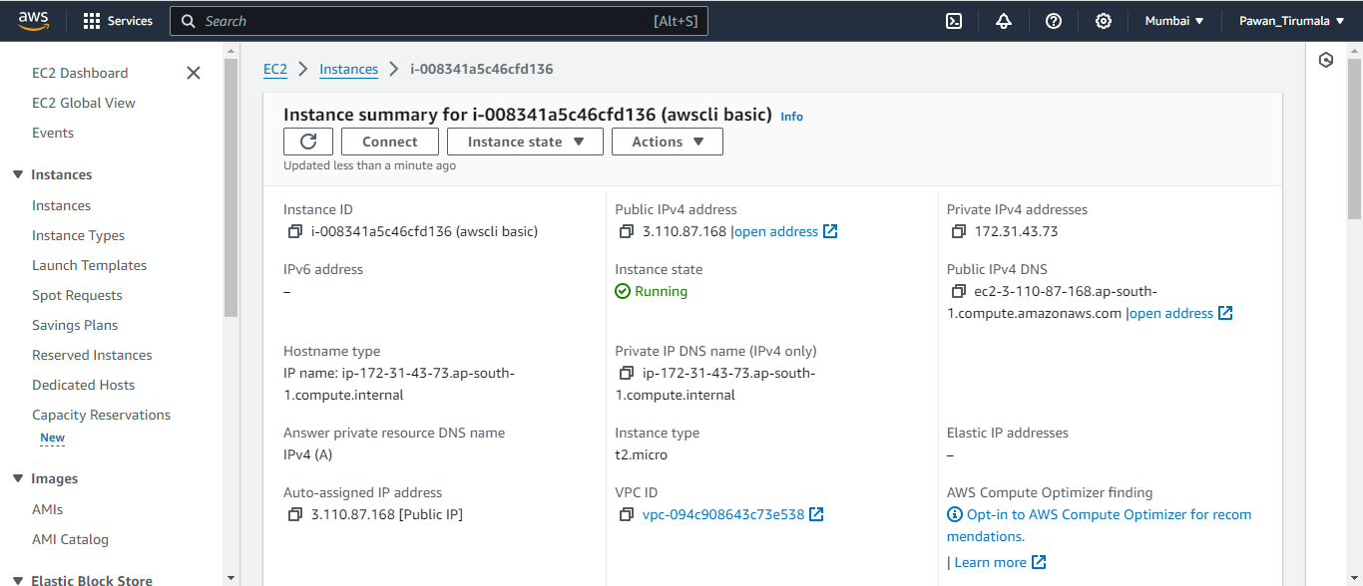

b. SSH into the newly created EC2 instance.

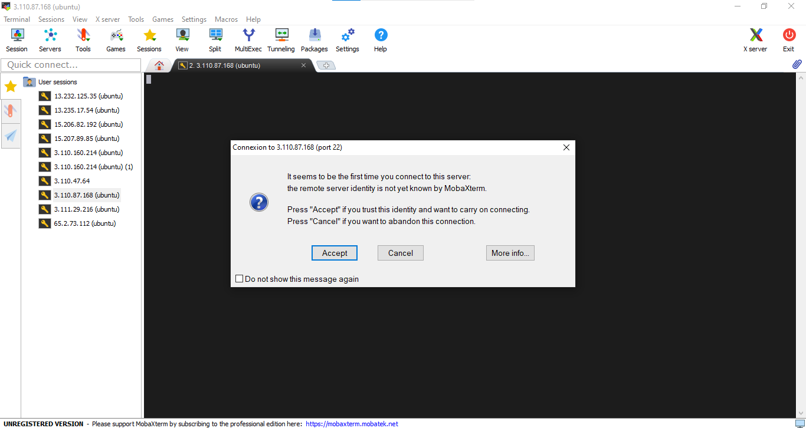

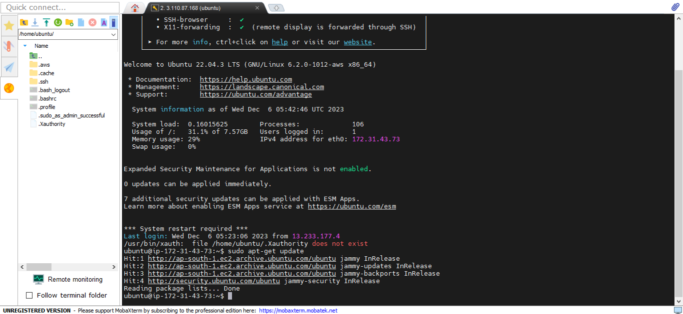

3.Infrastructure Provisioning:

a. Create a highly available VPC with multiple subnets in different availability zones.

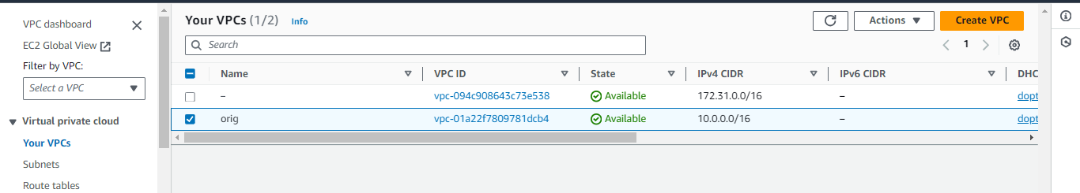

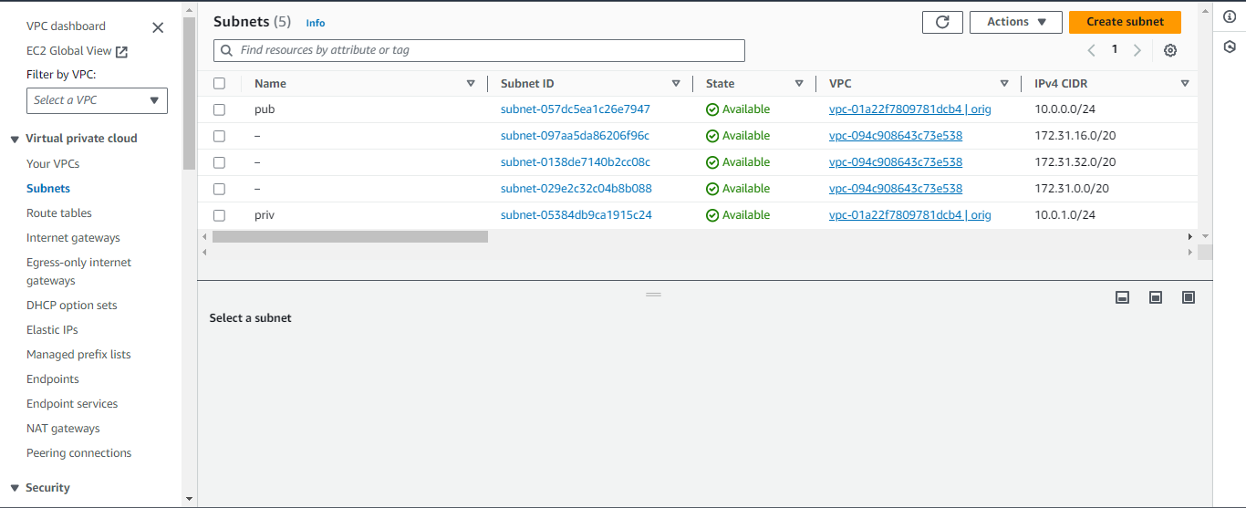

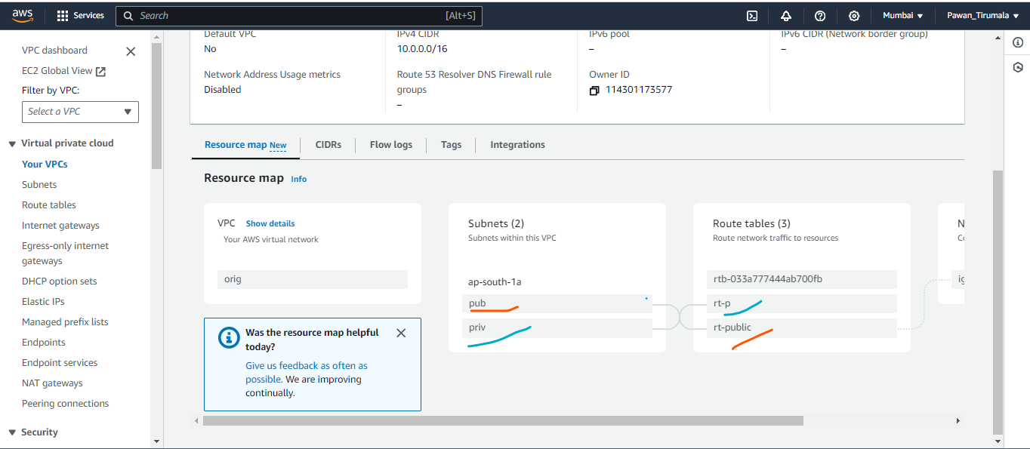

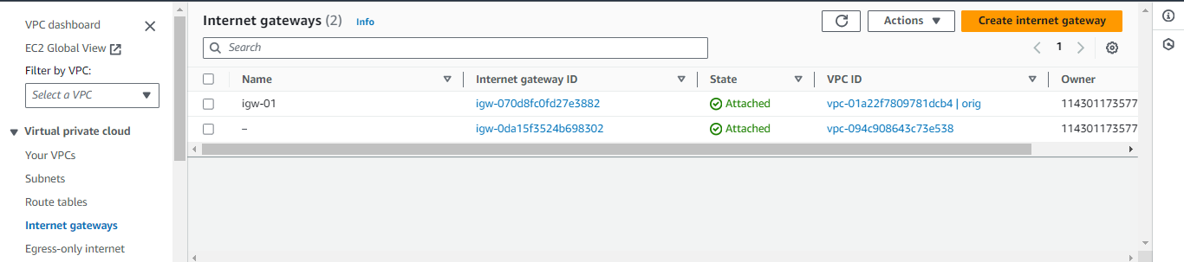

b. Deploy an EC2 instance in one of the subnets, configure security groups, and ensure it's accessible via SSH.

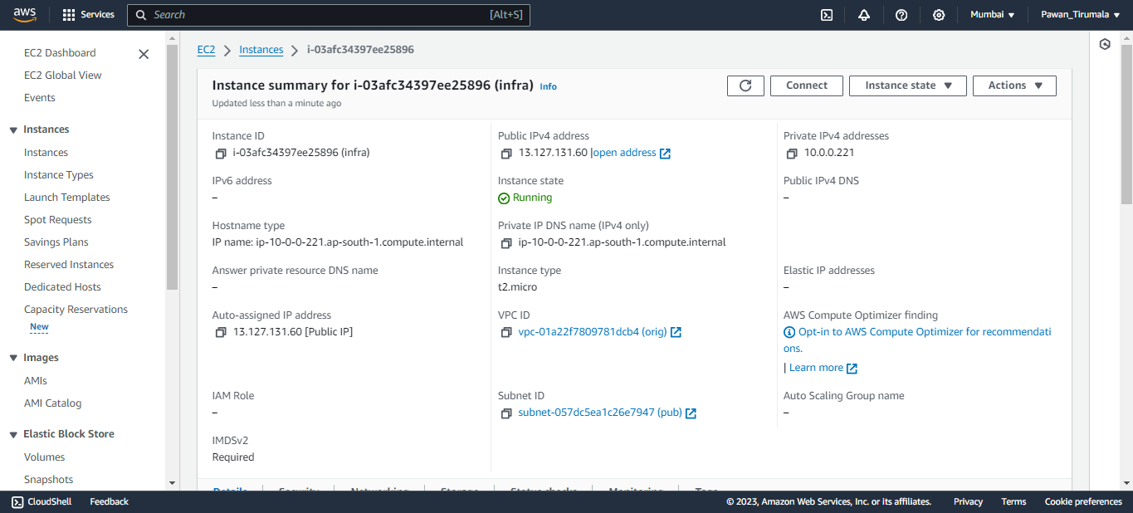

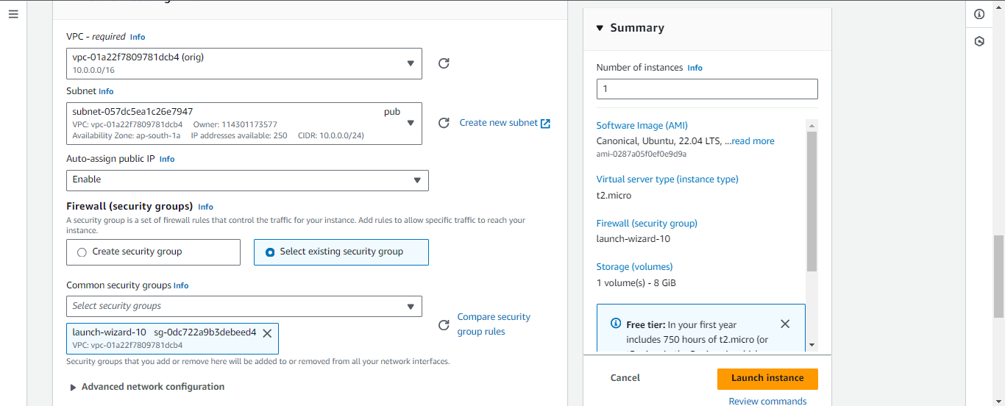

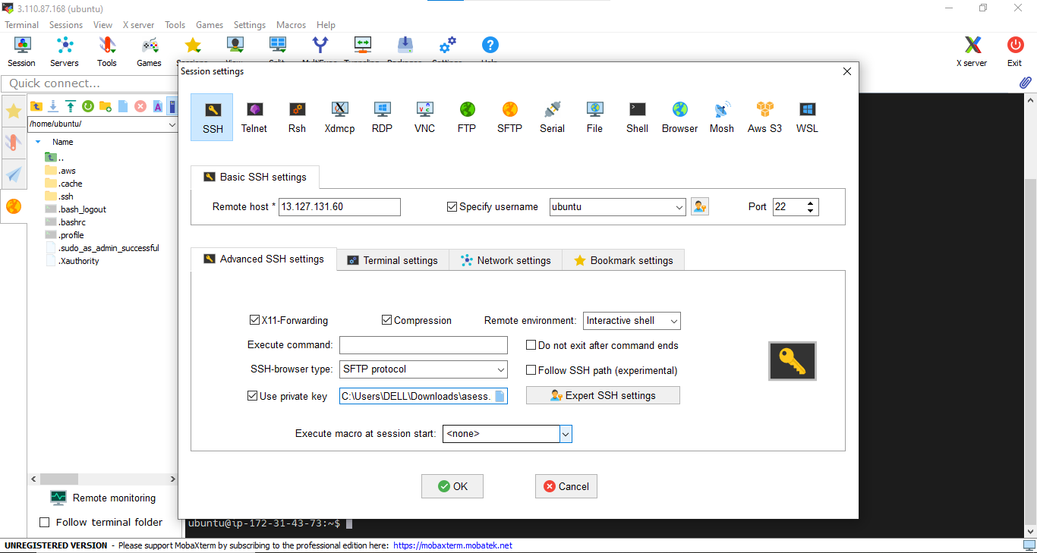

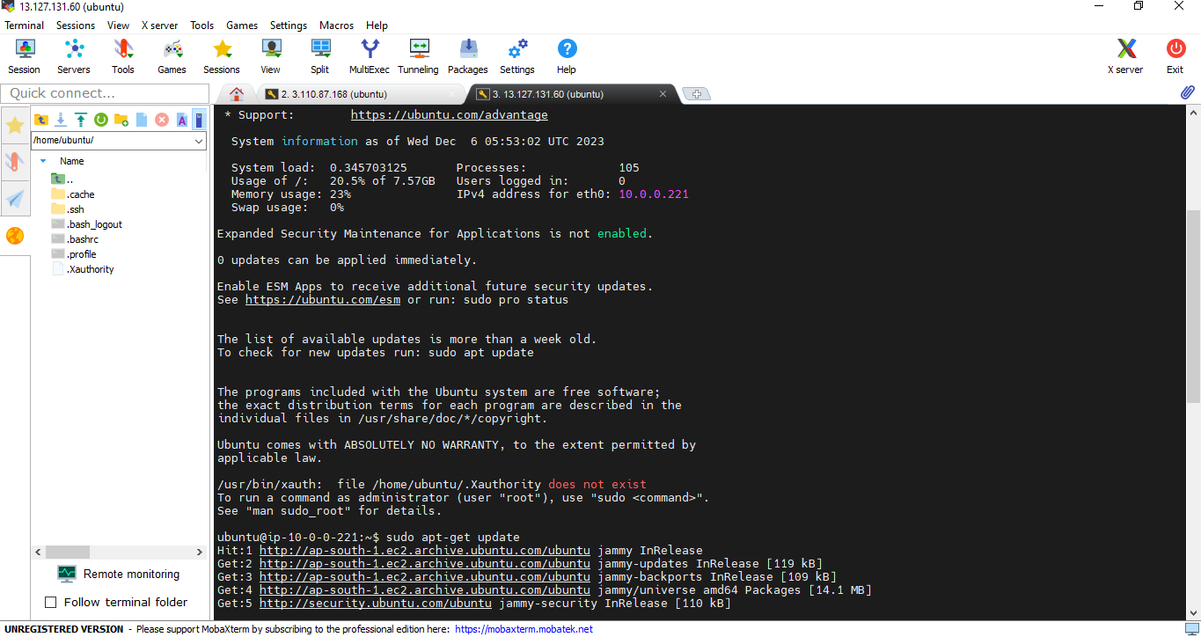

4.Automated Backup:

a. Configure automated daily backups for an RDS database using AWS RDS.

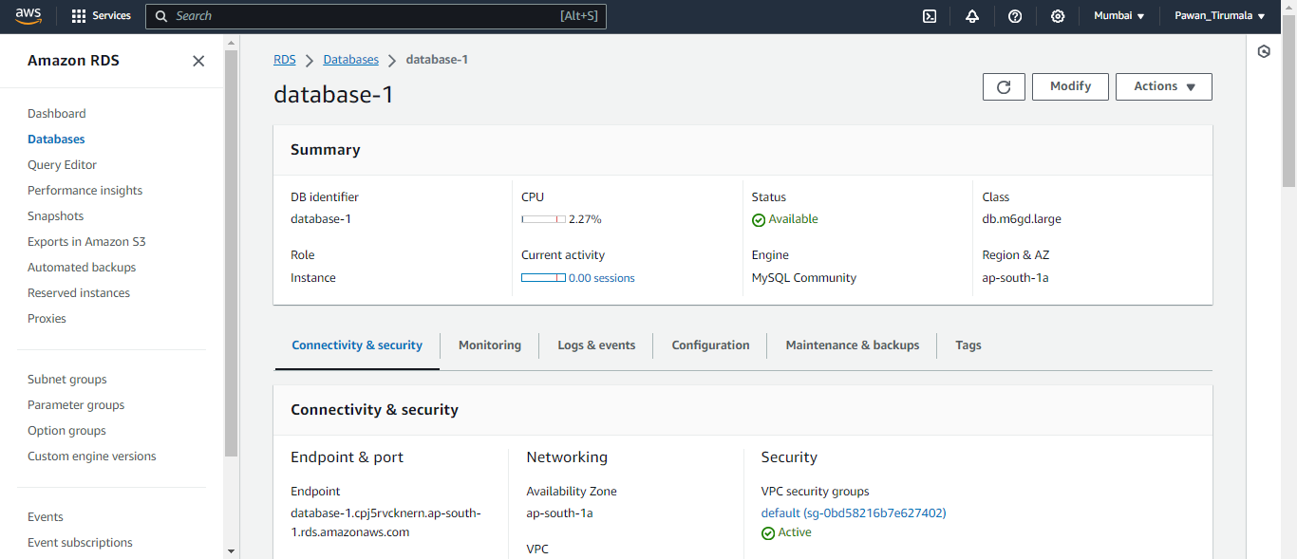

b. Verify the backup schedule and retention policy.

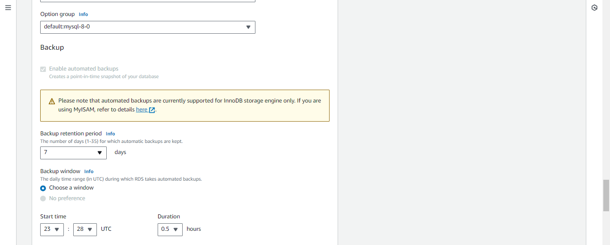

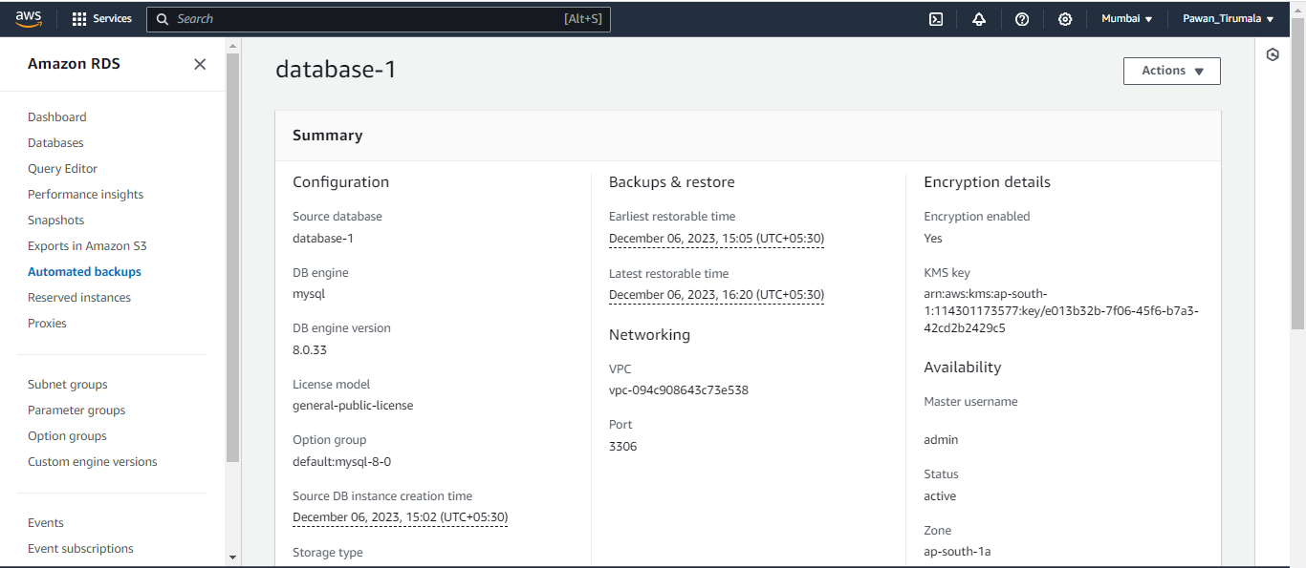

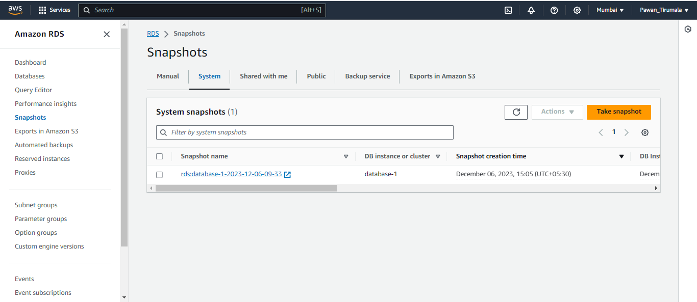

5.Simple Auto Scaling:

a. Create an Auto Scaling Group with a minimum and maximum instance count of 2 using AWS Auto

Scaling.

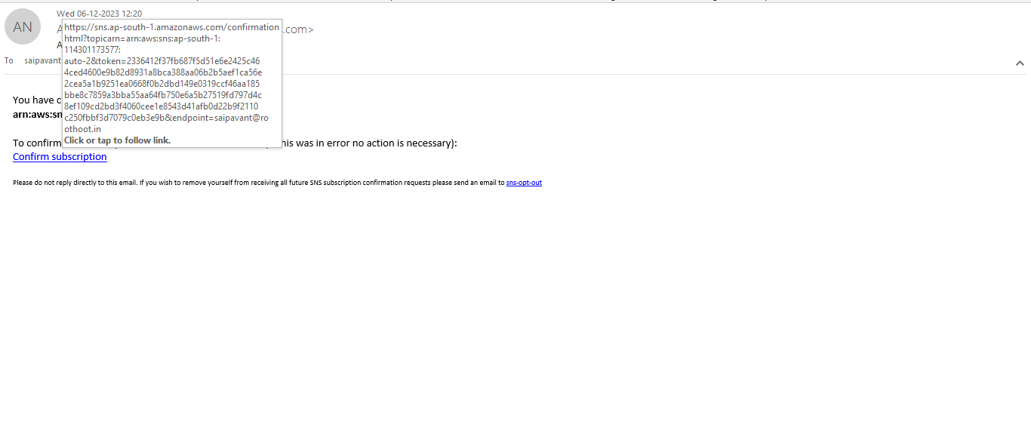

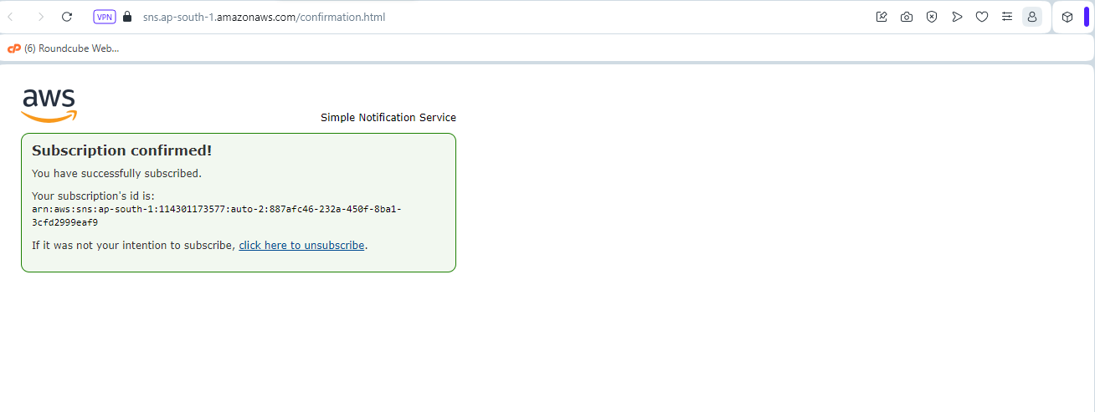

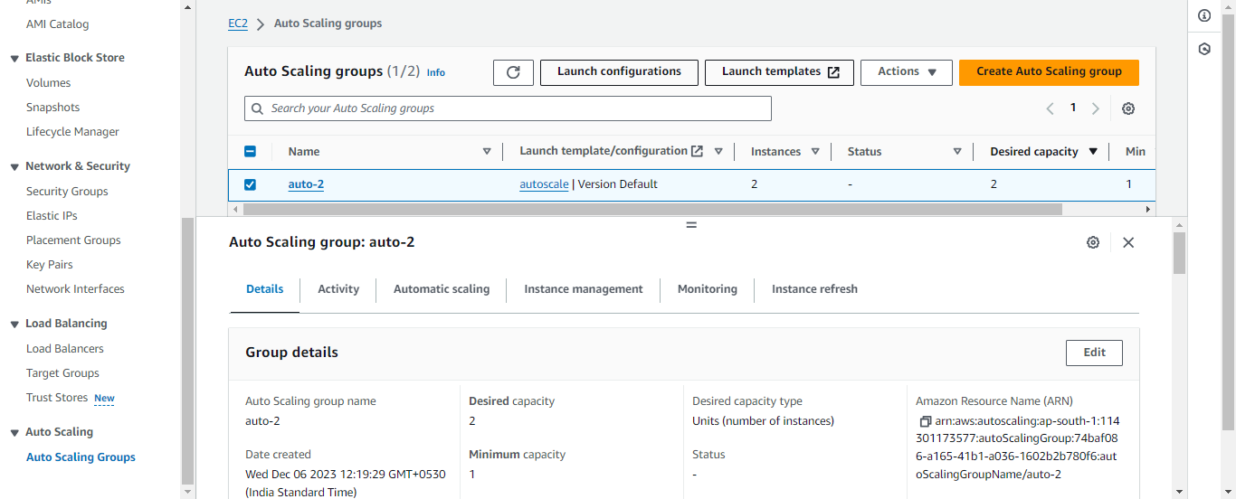

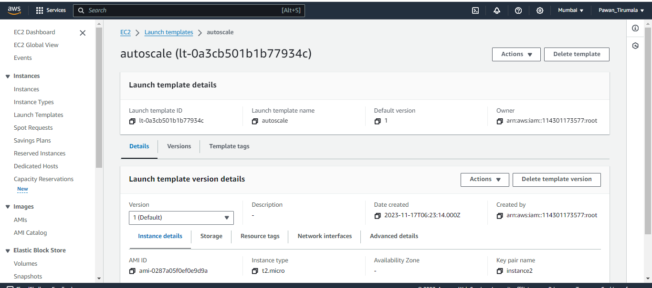

b. Monitor the scaling activities as instances are added or removed.

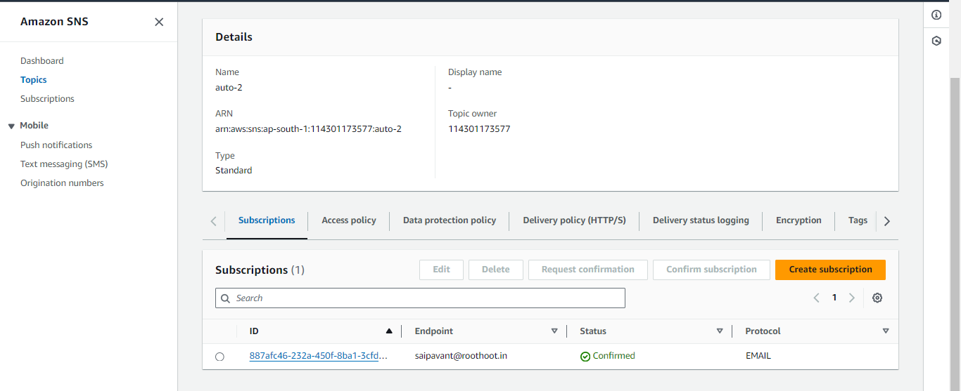

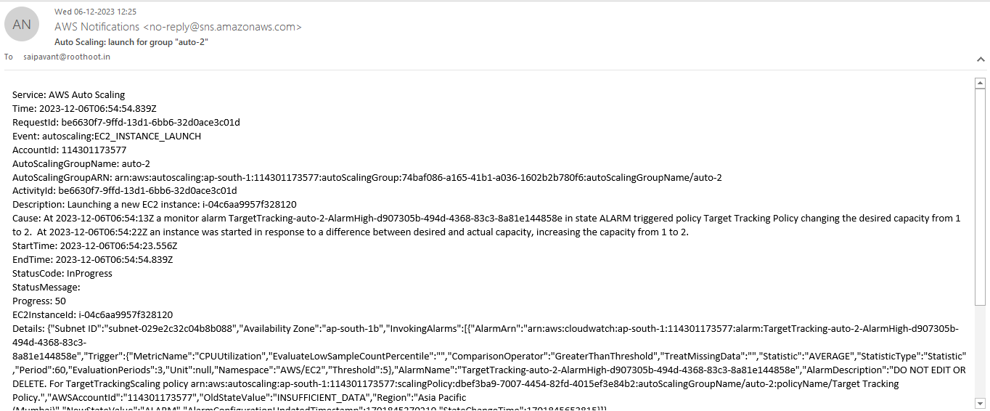

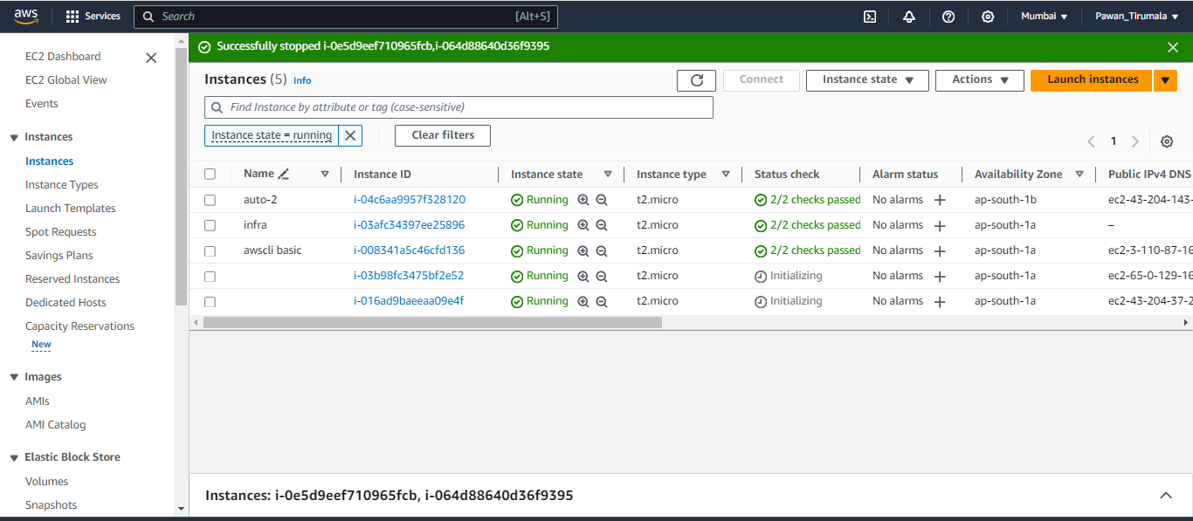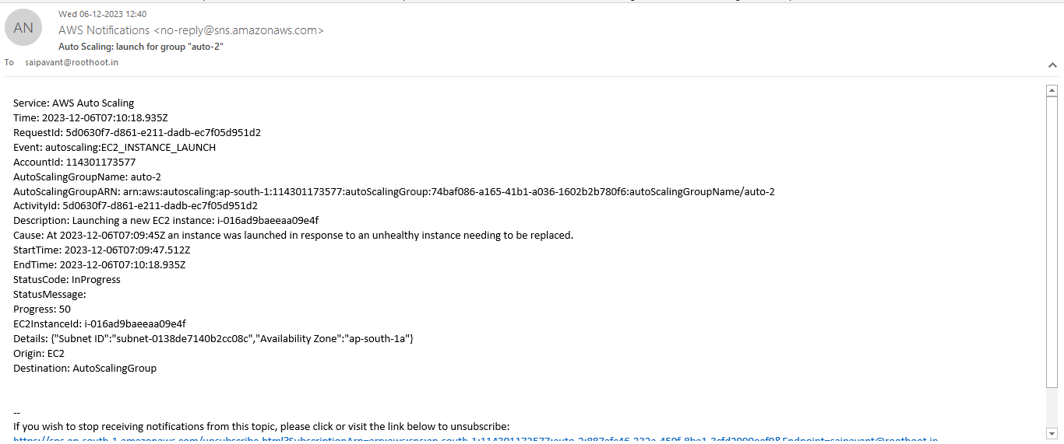

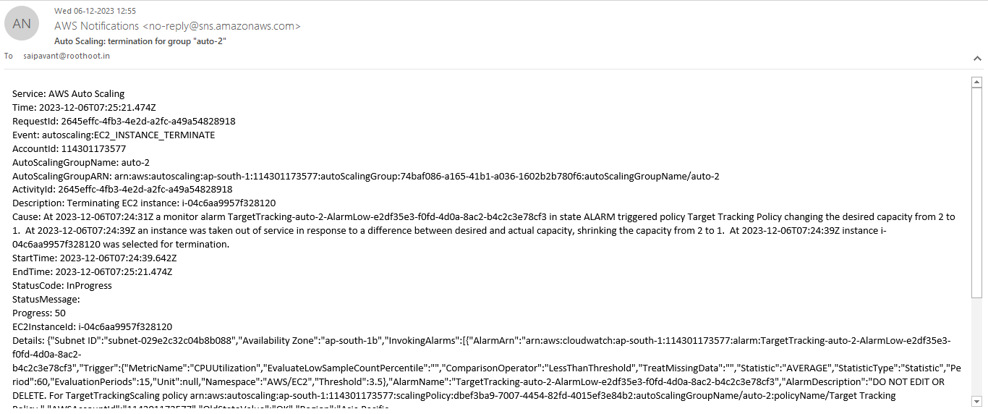

**B.Category: Medium (5 questions)**

1.Log Analysis:

a. Configure AWS CloudWatch to collect logs from an EC2 instance.

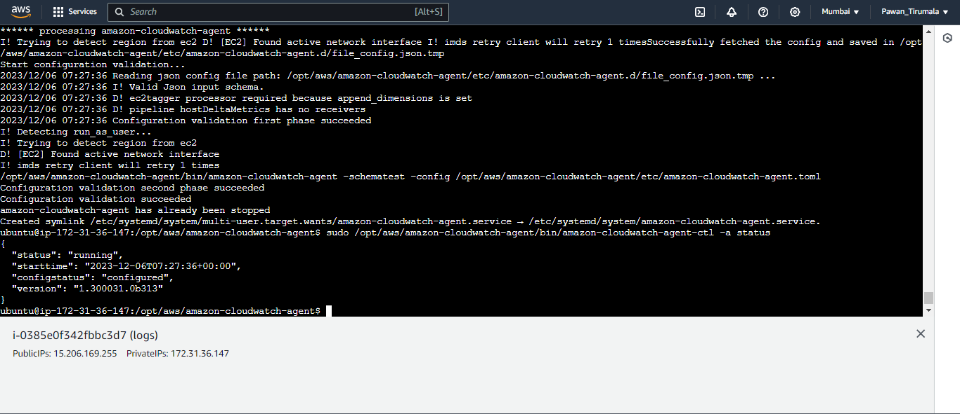

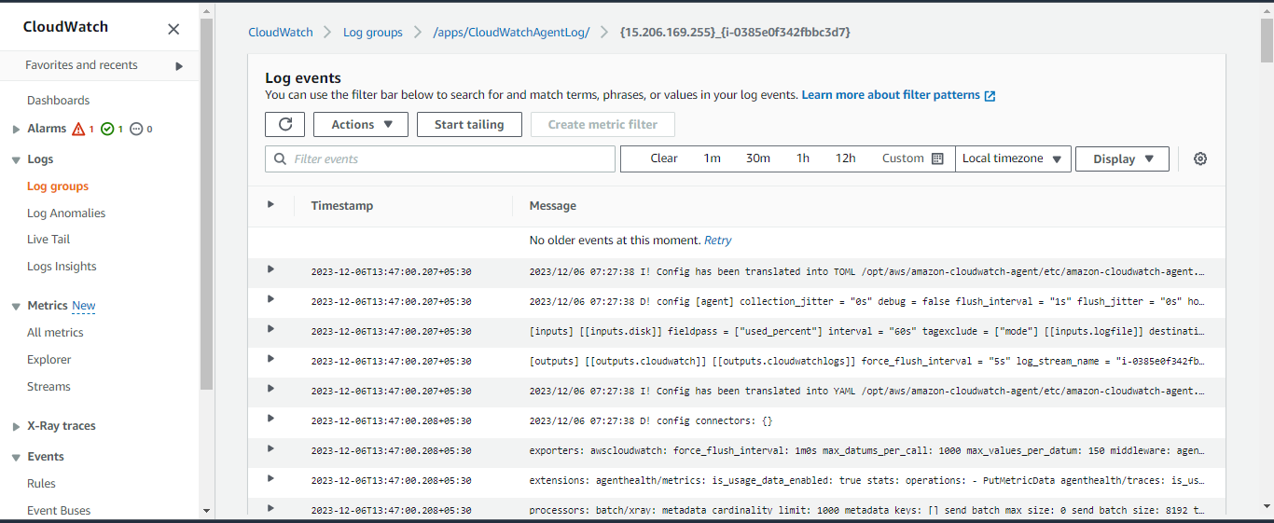

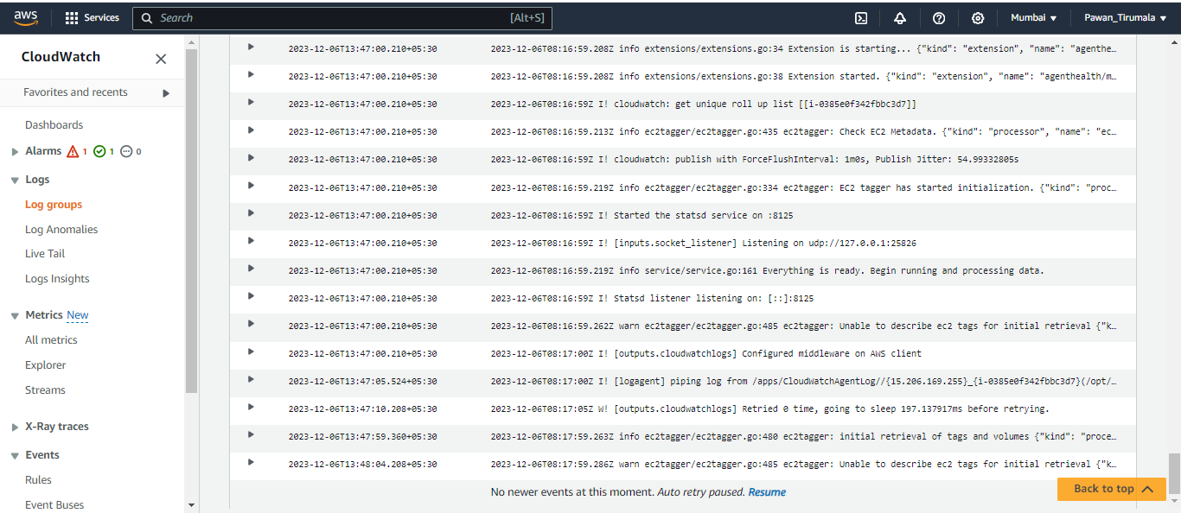

b. Create an alarm based on specific log events and set up a notification.

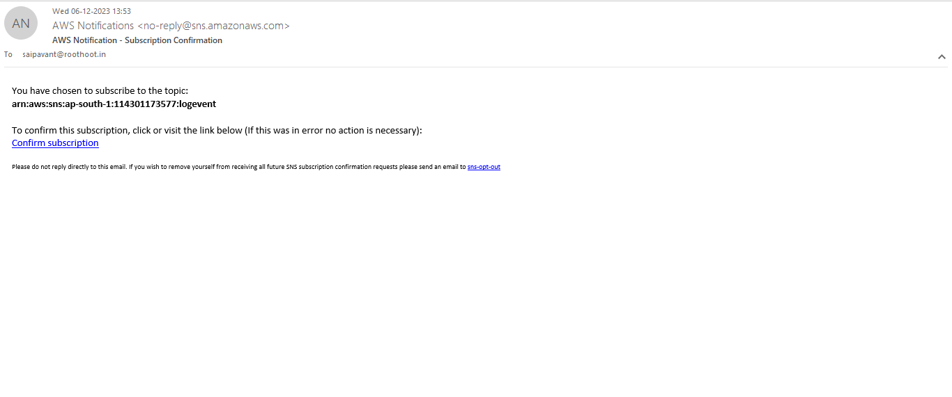

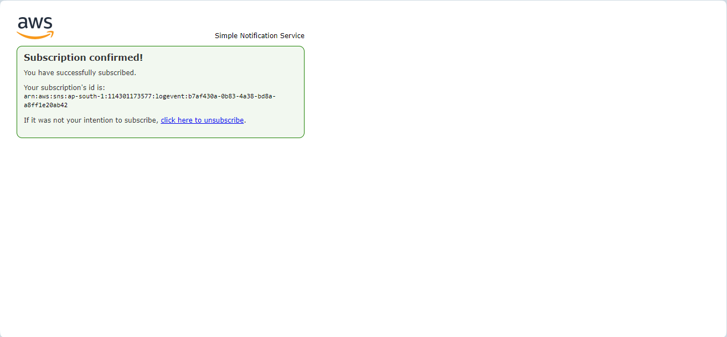

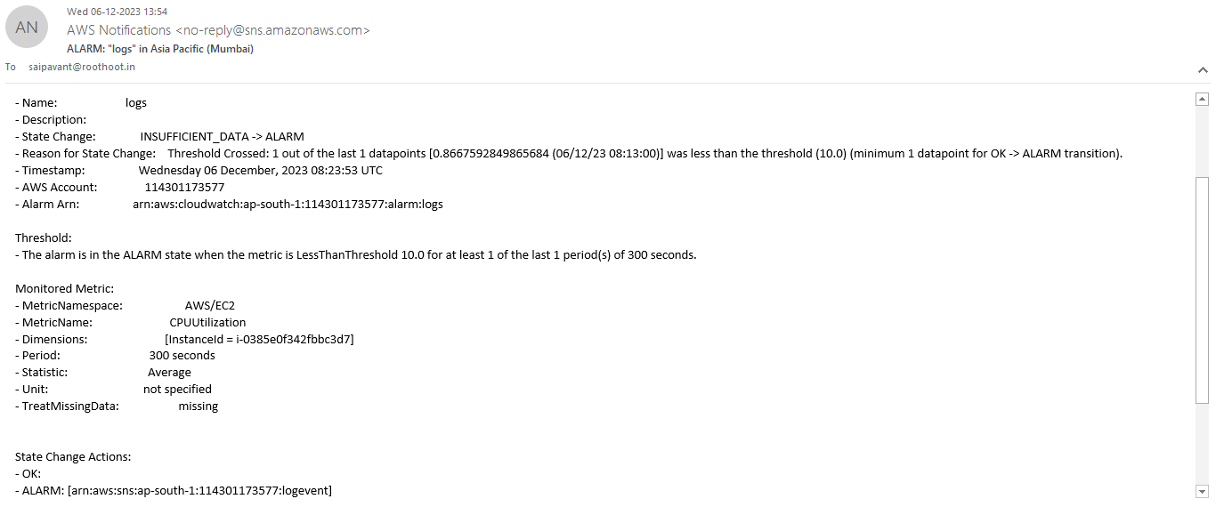

2.Load Balancing:

.a. Set up an Elastic Load Balancer (ELB) to distribute traffic to multiple EC2 instances

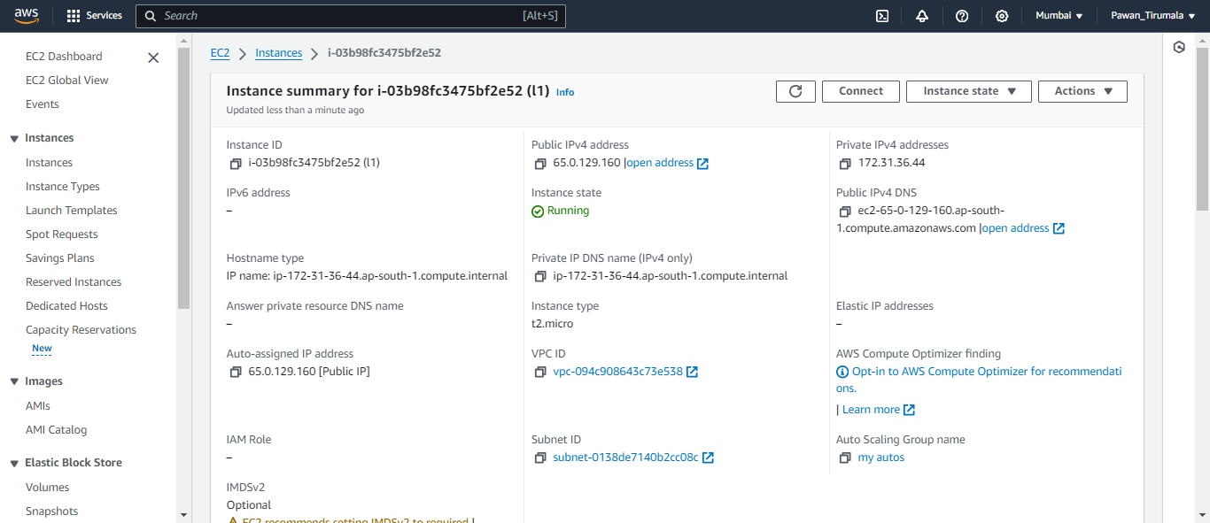

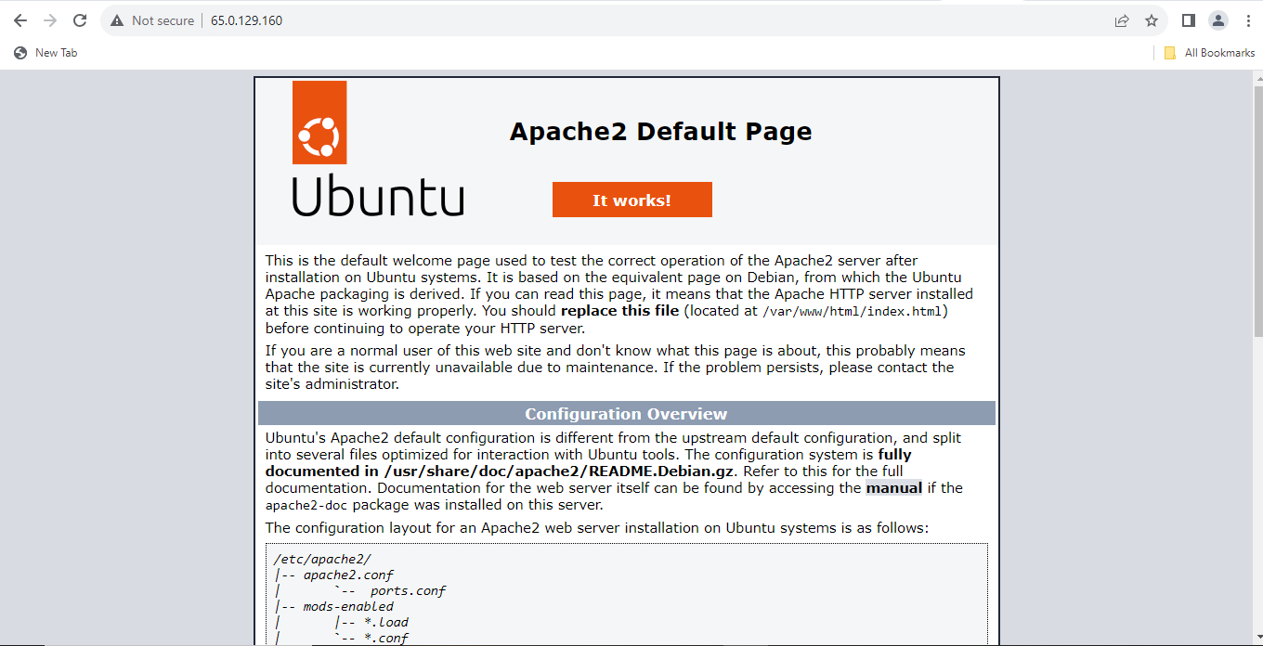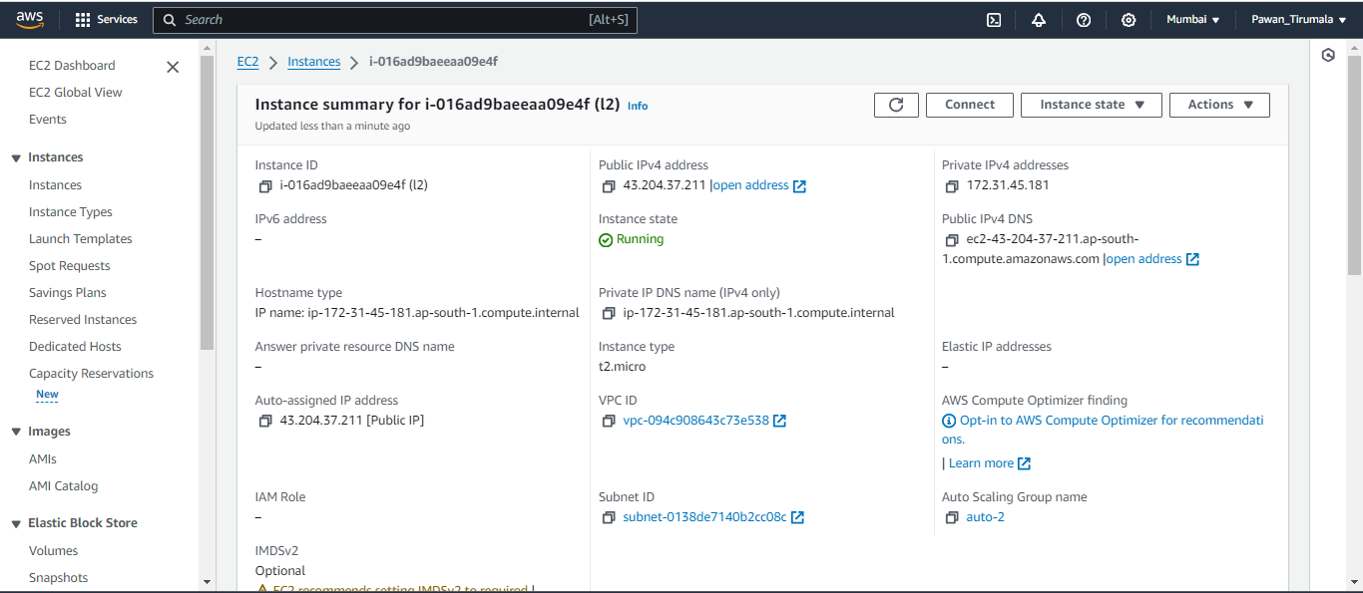

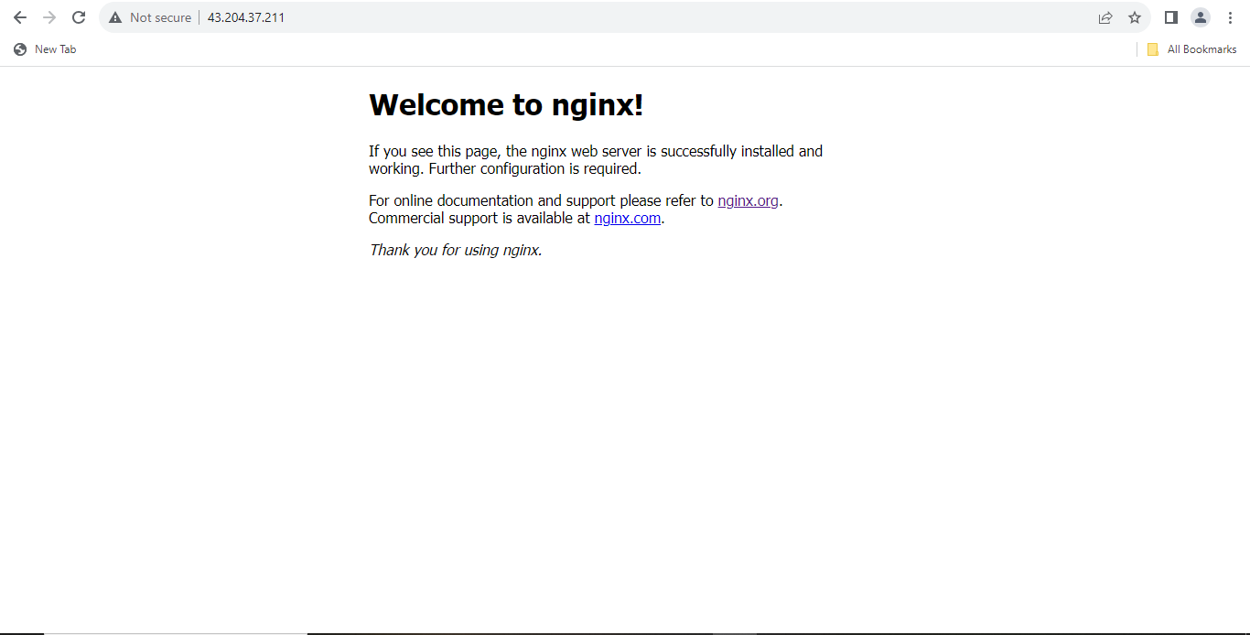

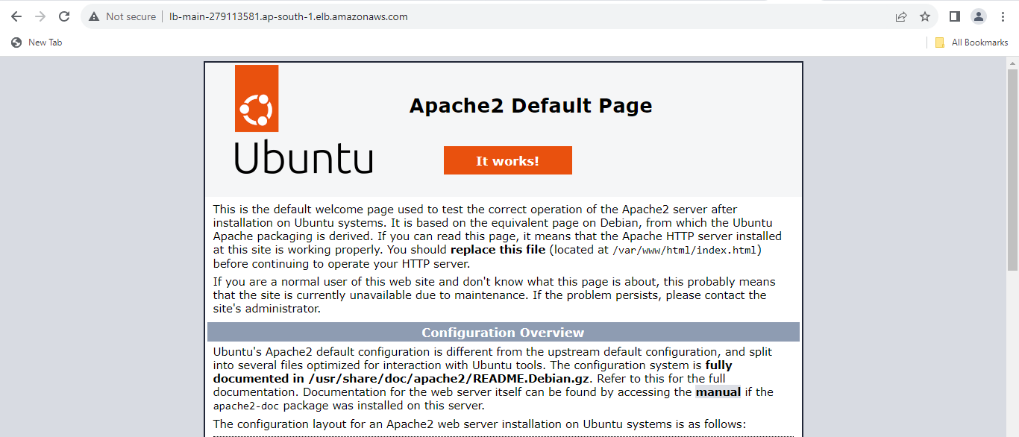

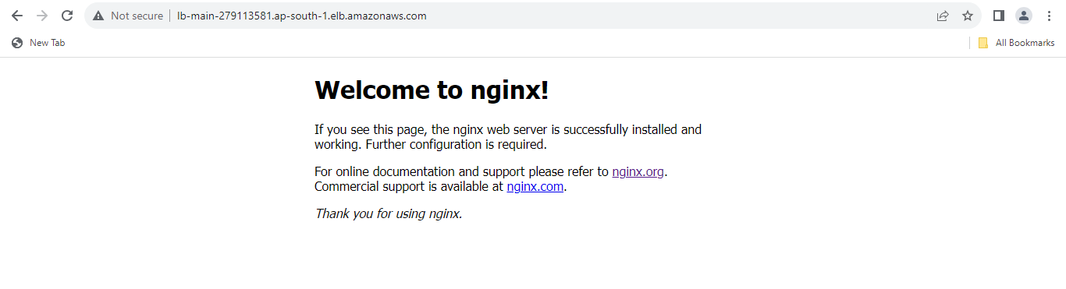

b. Monitor the performance and health of the instances behind the ELB.

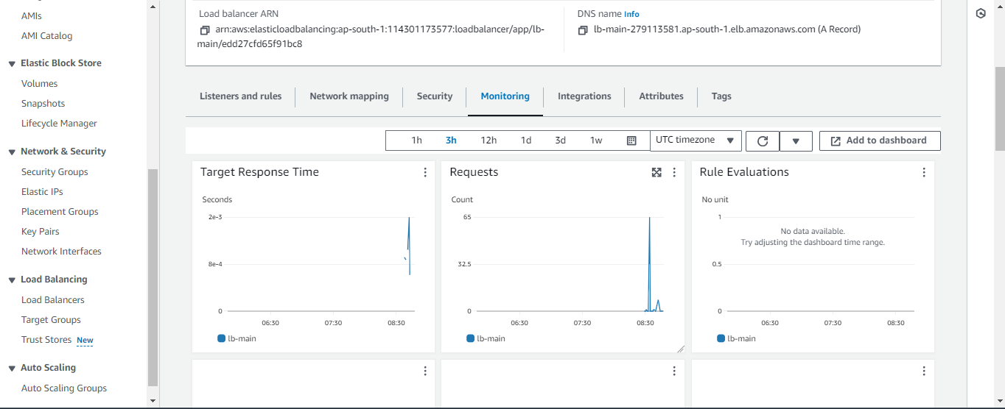

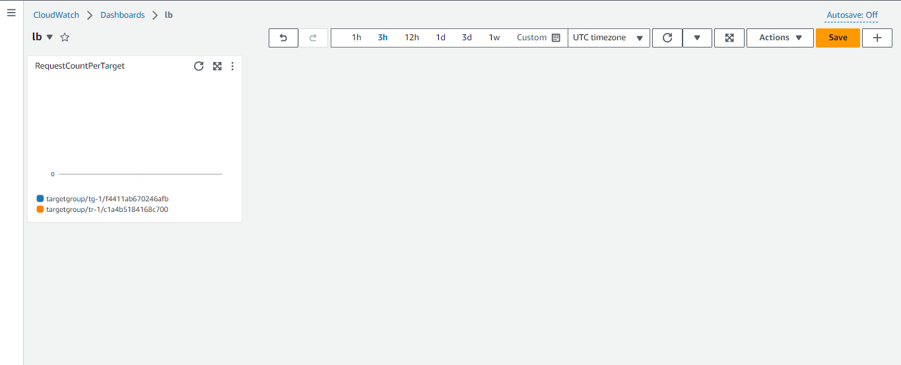

3.High Availability and Disaster Recovery:

a. Set up cross-region replication for an S3 bucket and RDS database for disaster recovery.

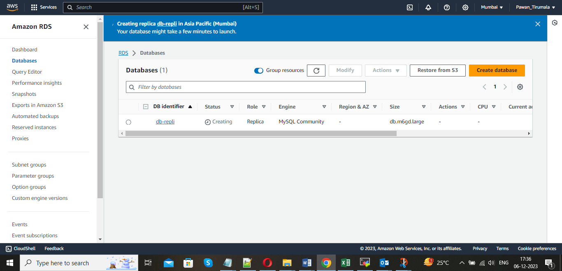

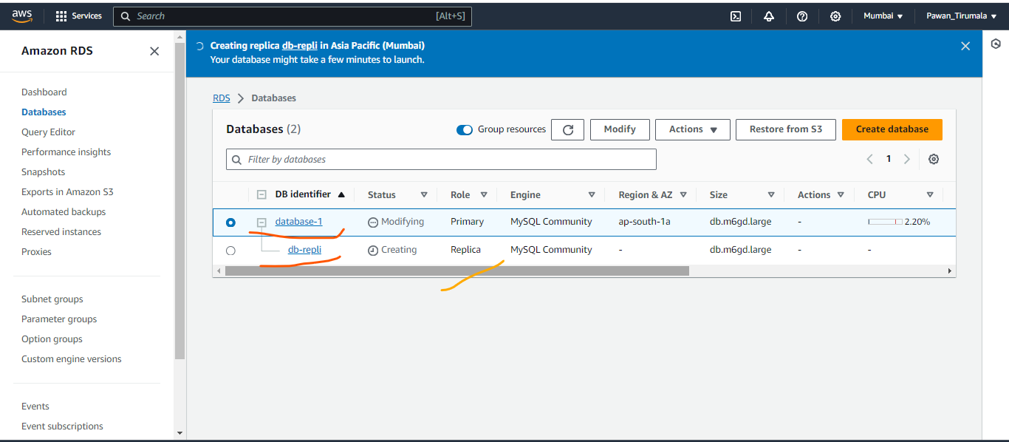

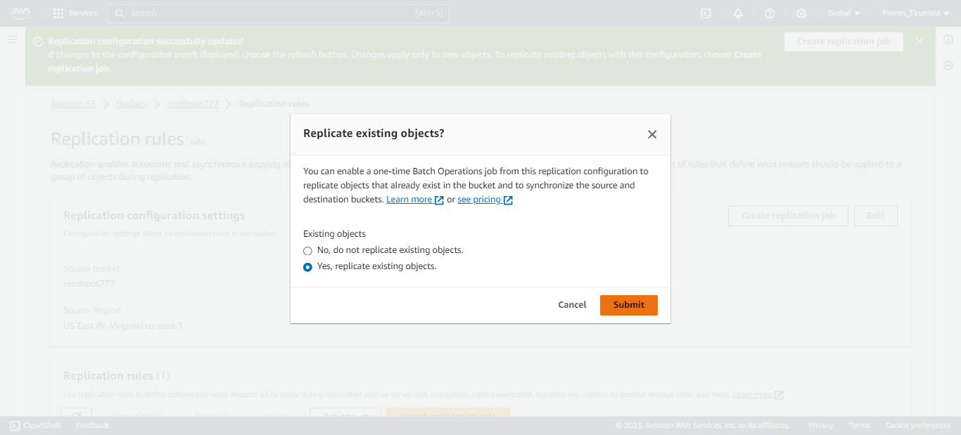

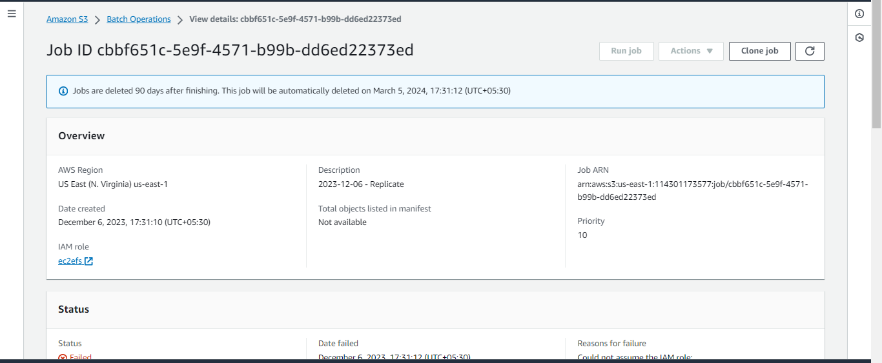

b. Perform a failover test and validate data consistency.

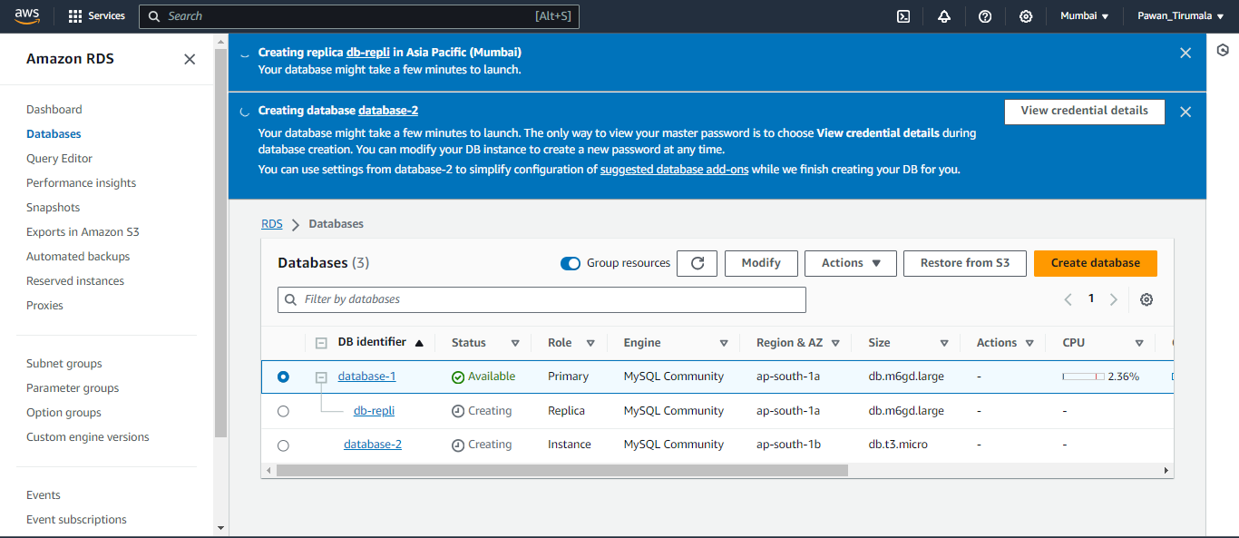

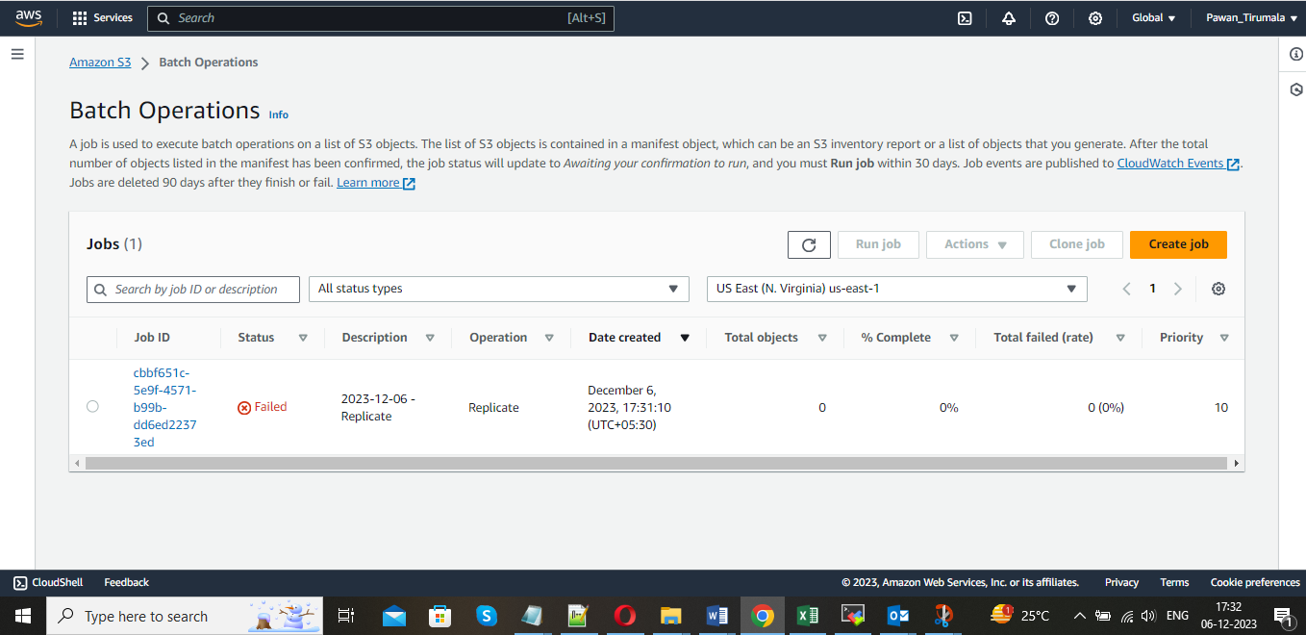

4. Web applications:

a. Deploy a tomcat and Nginx in a single Ec2 server. If possible, deploy a sample web application on it.

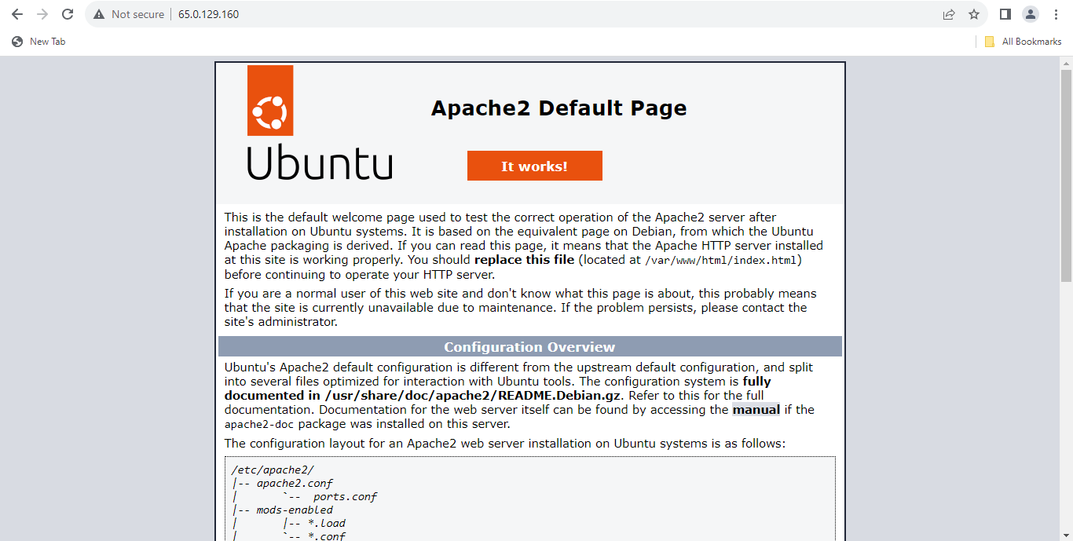

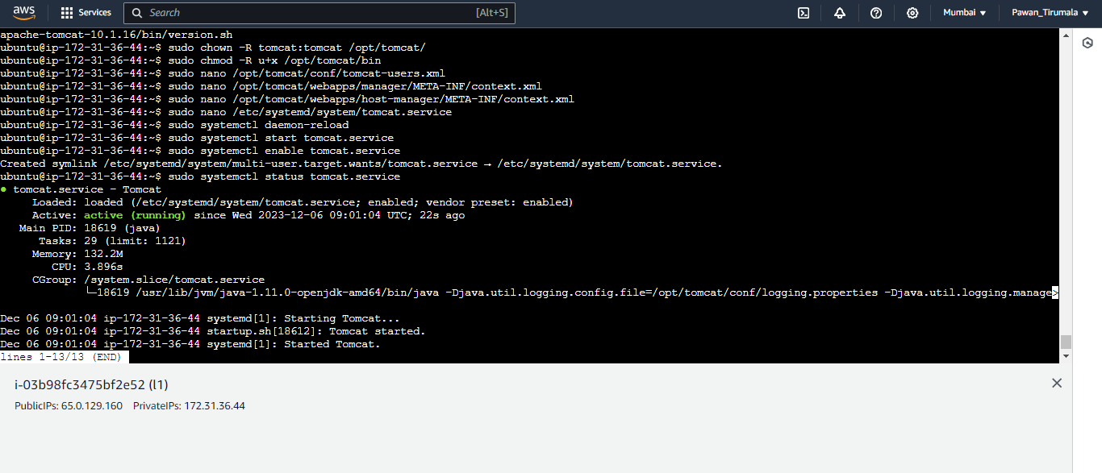

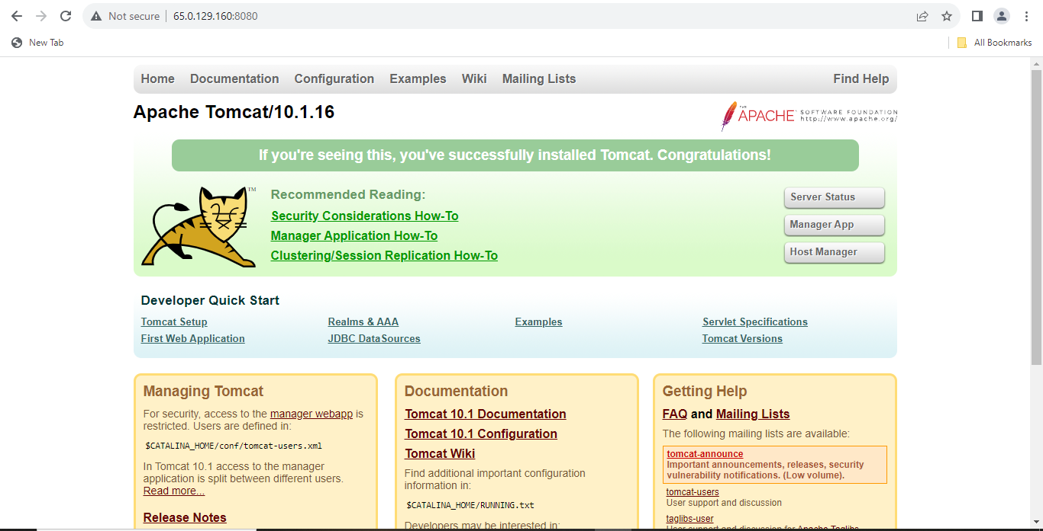

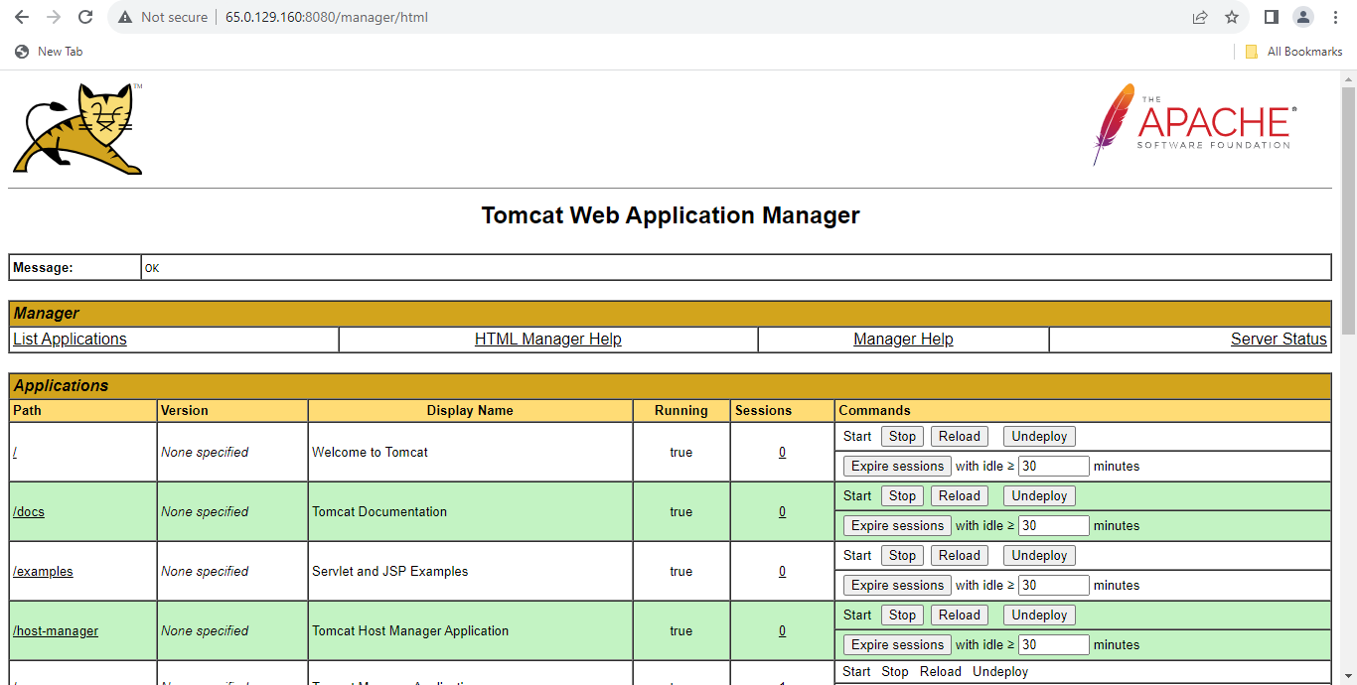

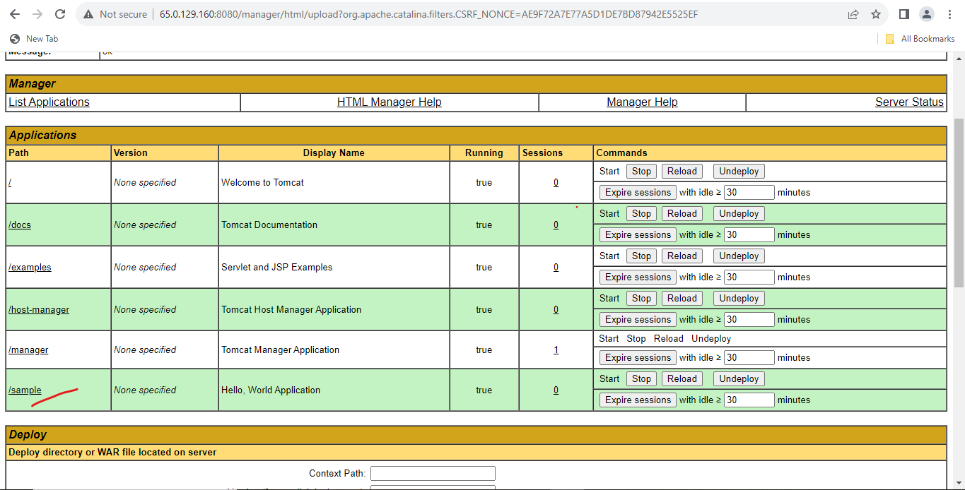

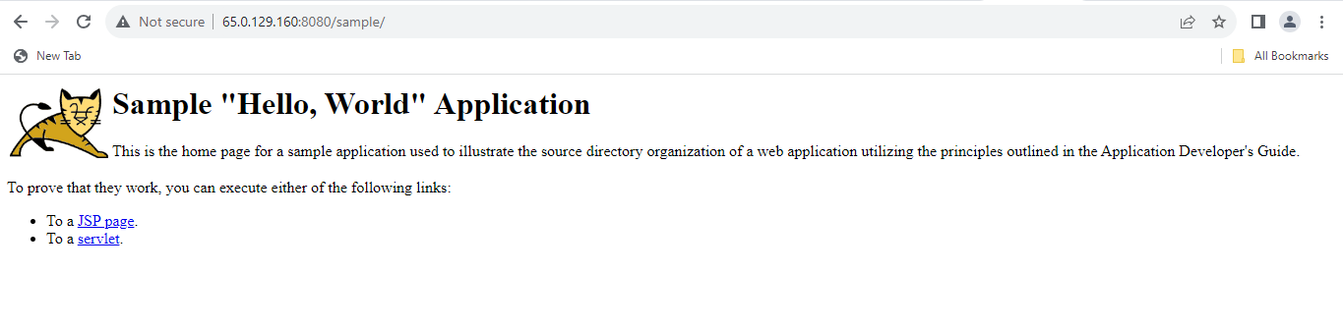

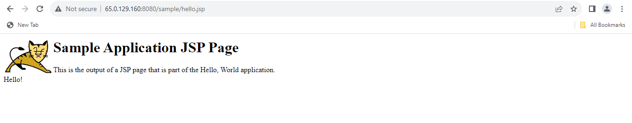

5. Volumes concept.

a. Create an EFS volume.

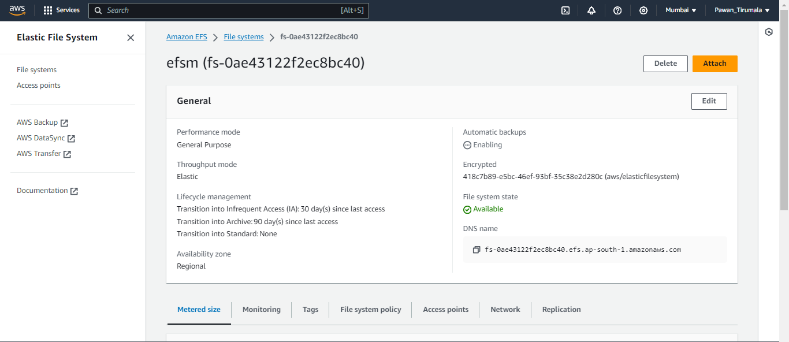

b. Mount the above volume to two Ec2 servers. Observer the file sharing when creating and deleting

the files.

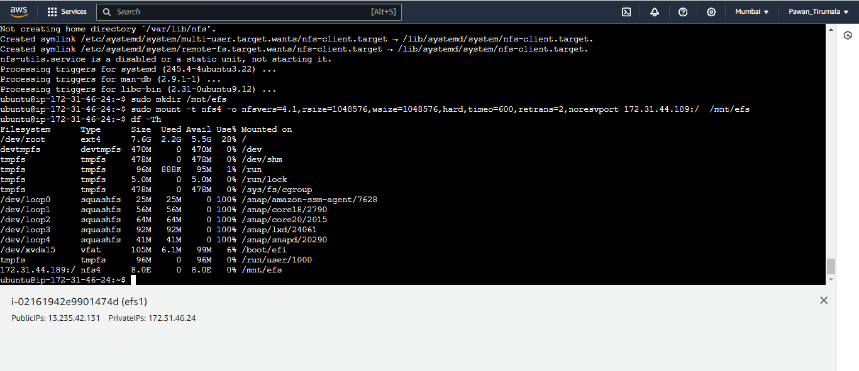

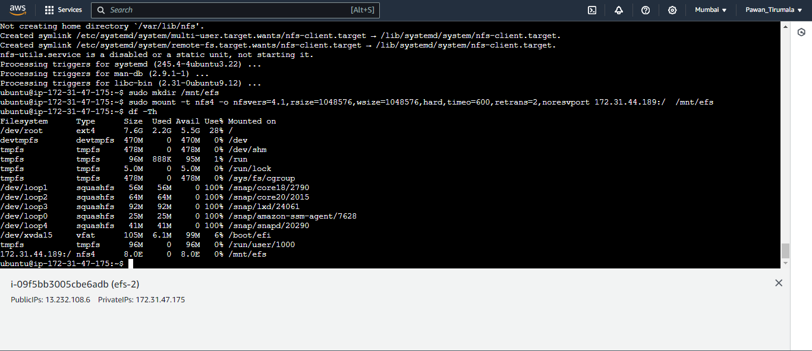

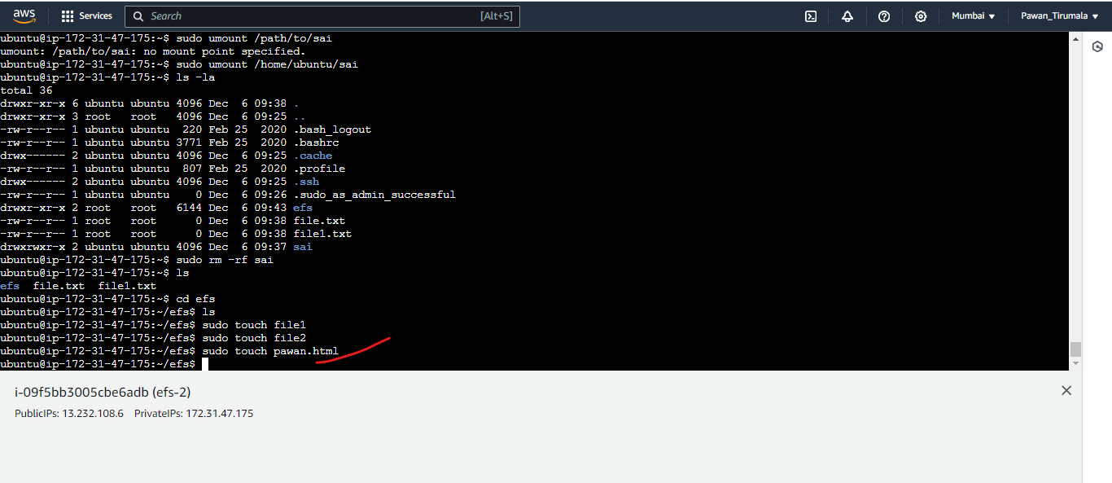

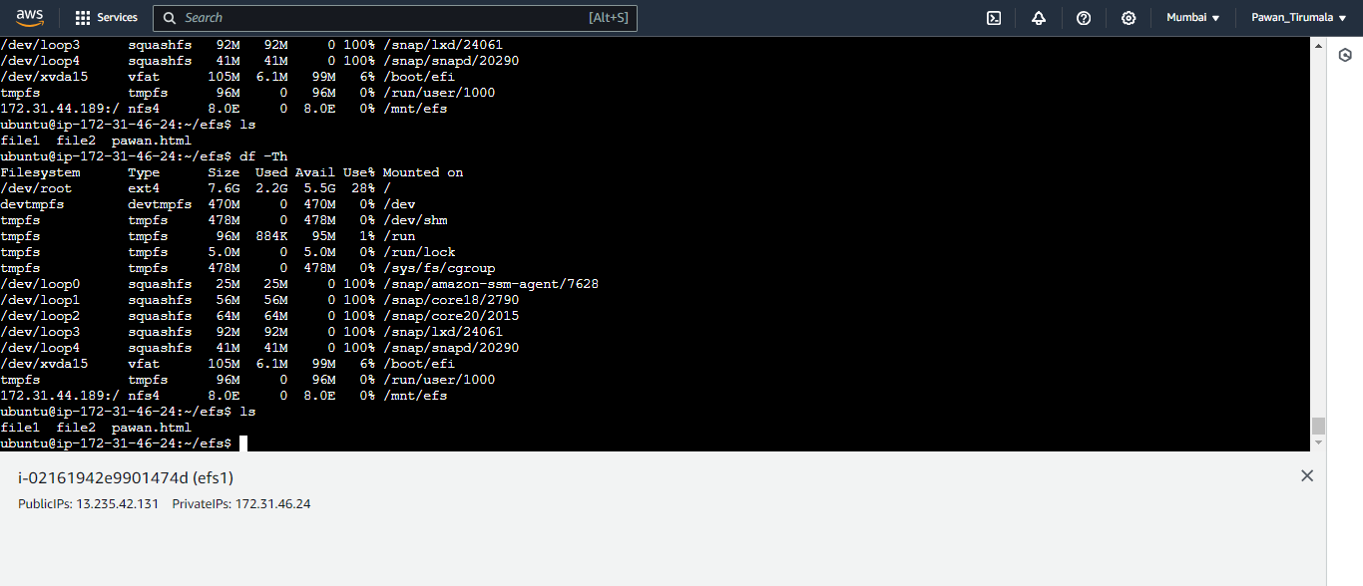

**C.Category: Complex**

1.Advanced Auto Scaling:

a. Create an Auto Scaling Group with dynamic scaling policies based on CPU utilization and custom metrics.

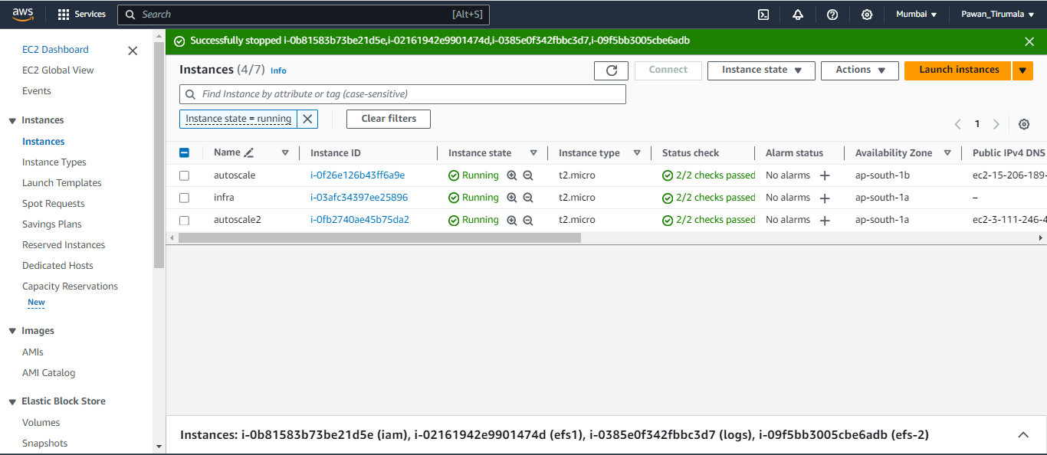

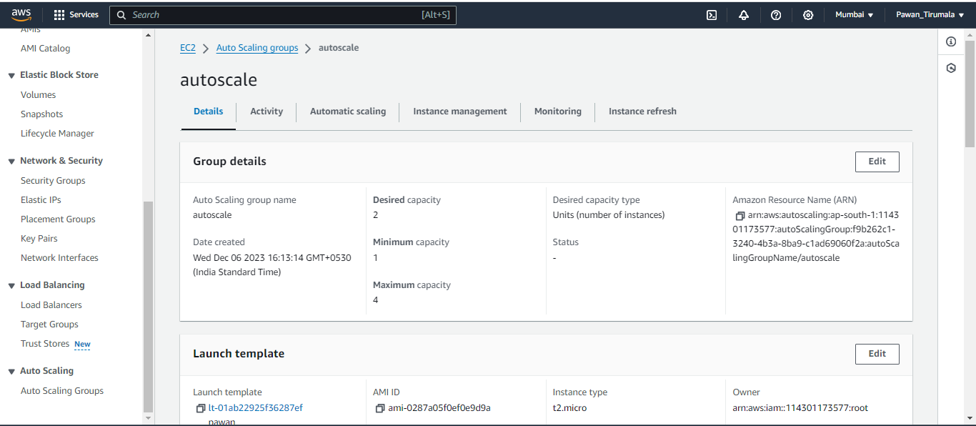

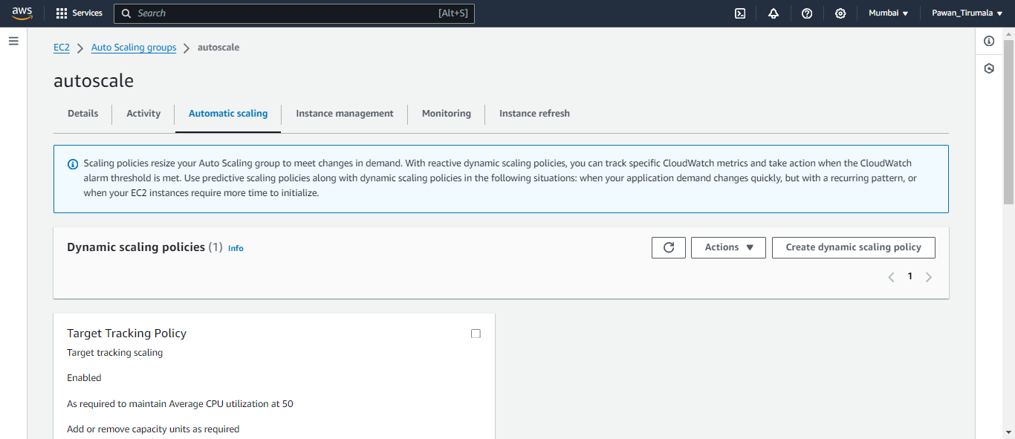

b. Monitor the scaling actions during traffic spikes and downturns. Apply CPU spikes manually through commands.

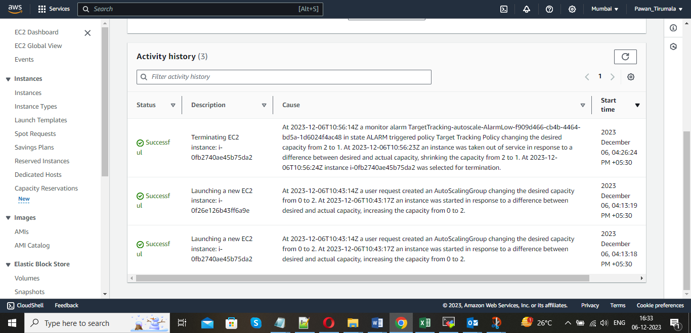

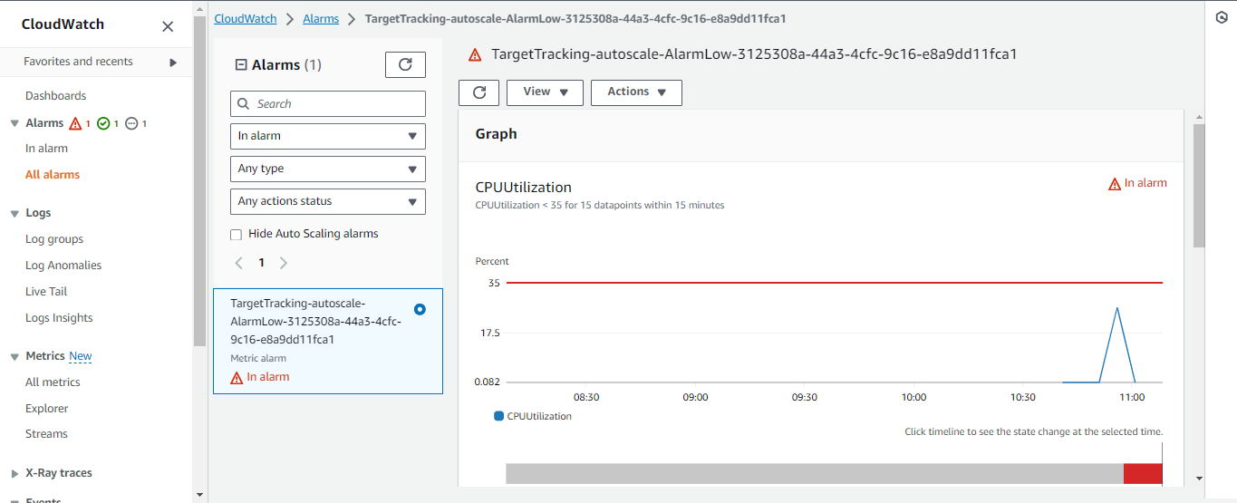

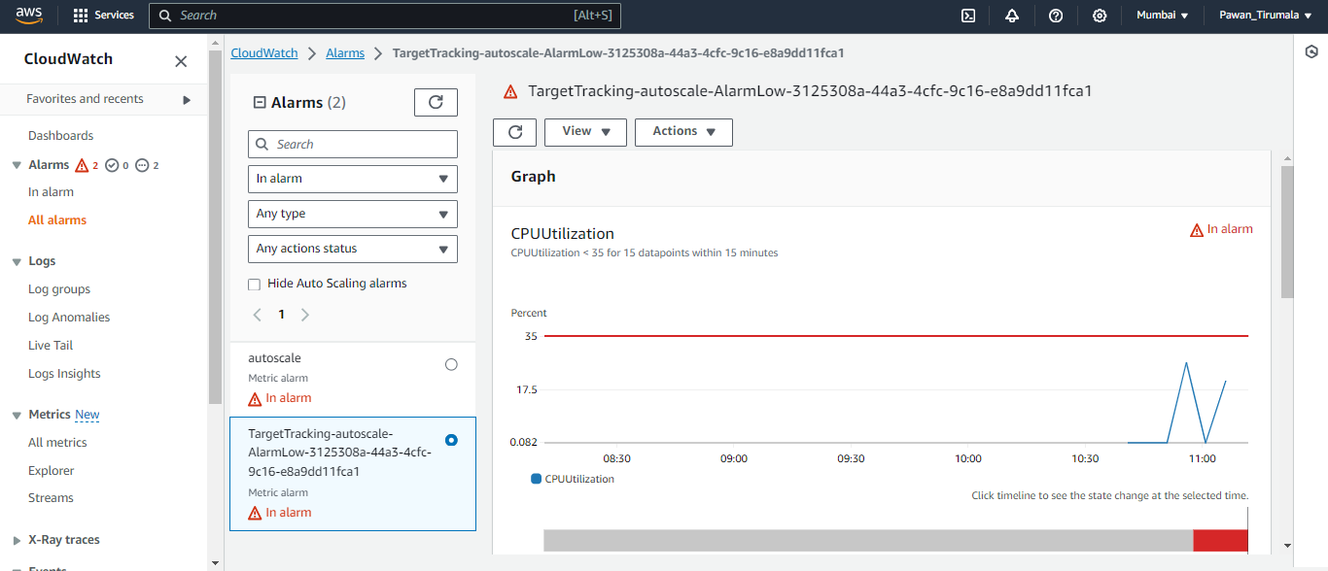

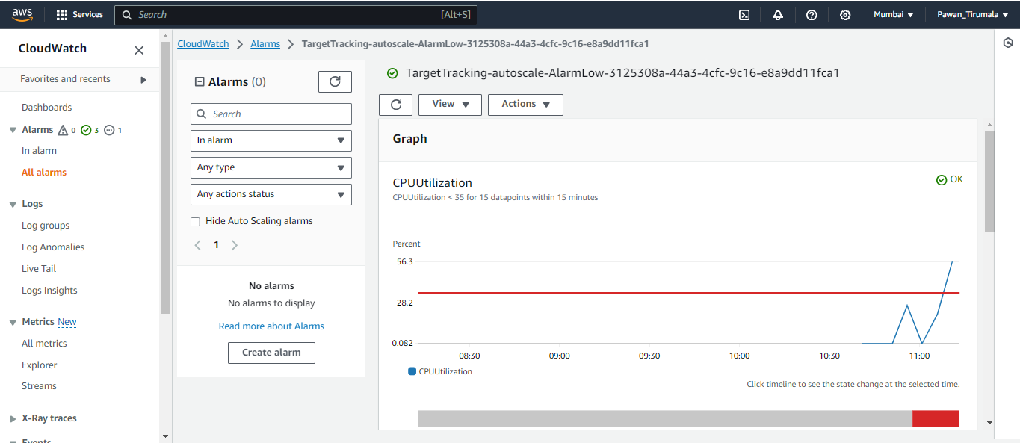

2.Multi-Region Deployment:

a. Deploy the same application in two AWS regions and configure cross-region failover using Route 53.

b. Test the failover by shutting down resources in one region and verifying that traffic is redirected to the other.

3.Serverless Application:

a. Develop and deploy a serverless application using AWS Lambda and API Gateway.

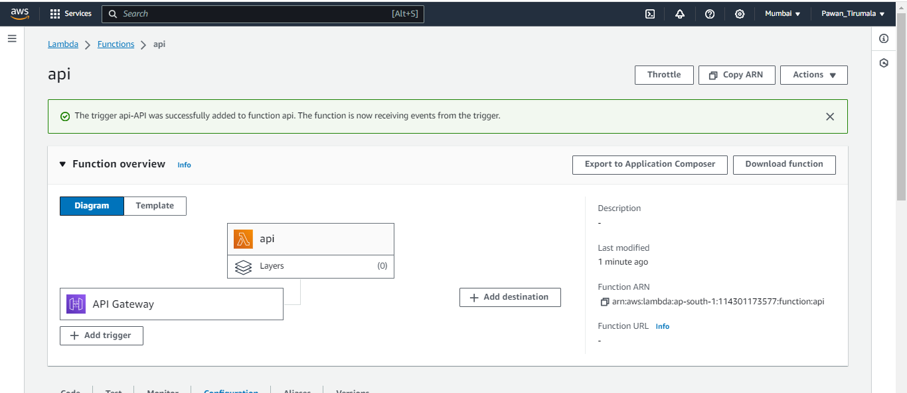

b. Create a simple API and ensure it is accessible via HTTP requests.

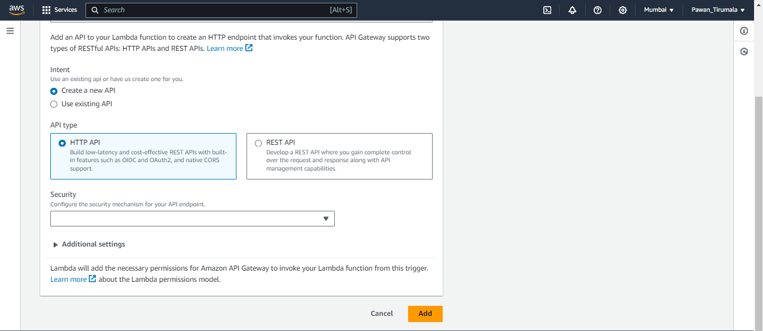

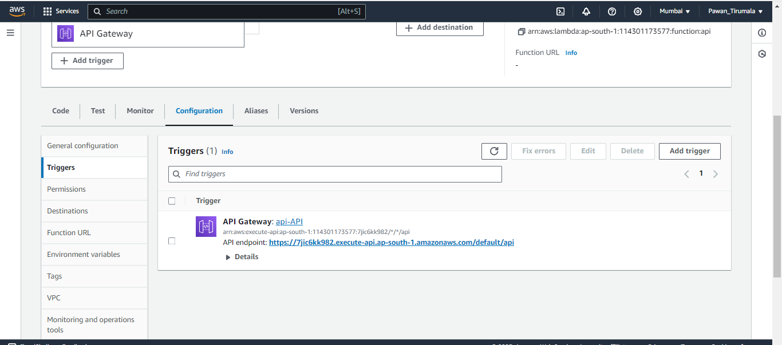

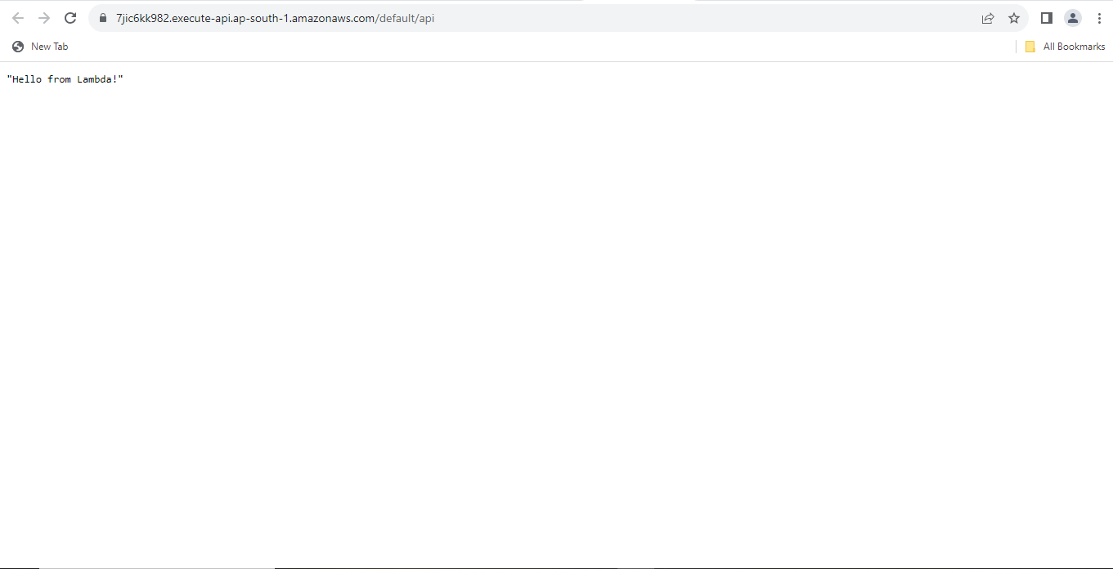

4.Networking

a. create VPC, subnets and routing policies ,NACLS ,IGW . Deploy an Ec2 server in the created vpc in the private subnet. Also deploy another server in your default VPC.

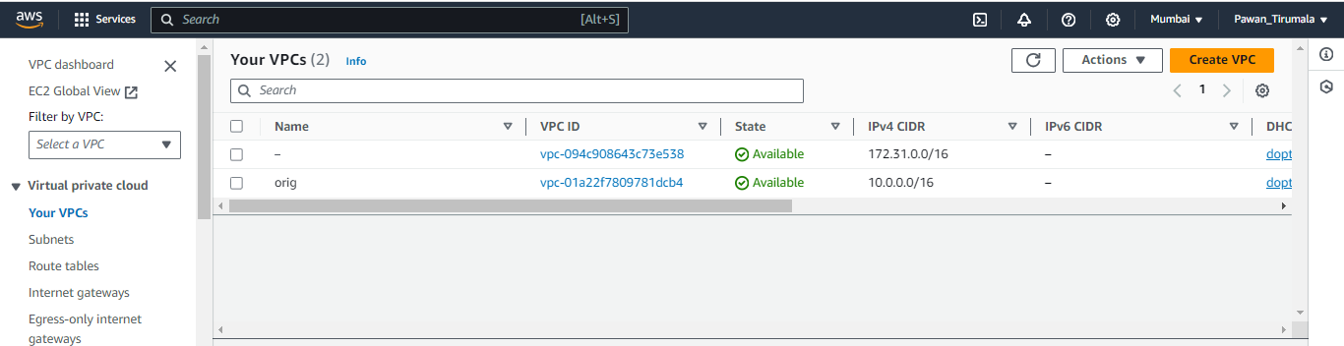

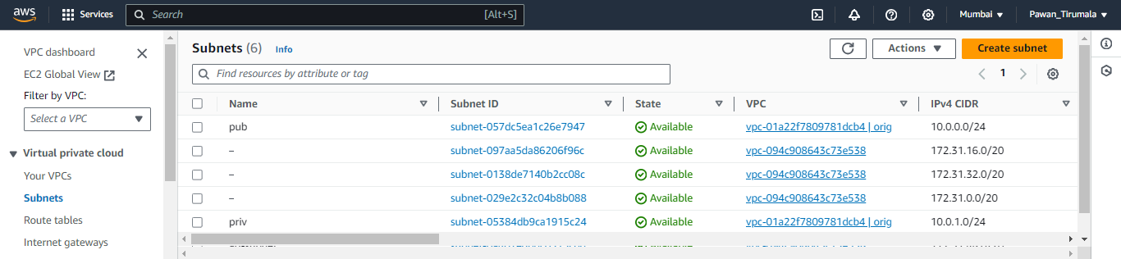

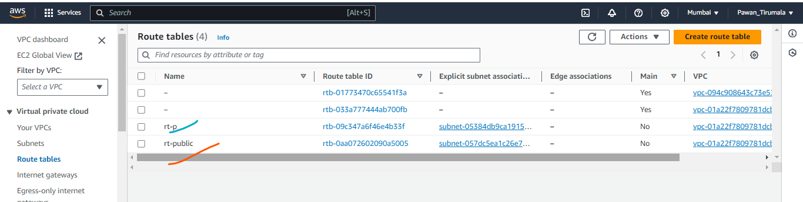

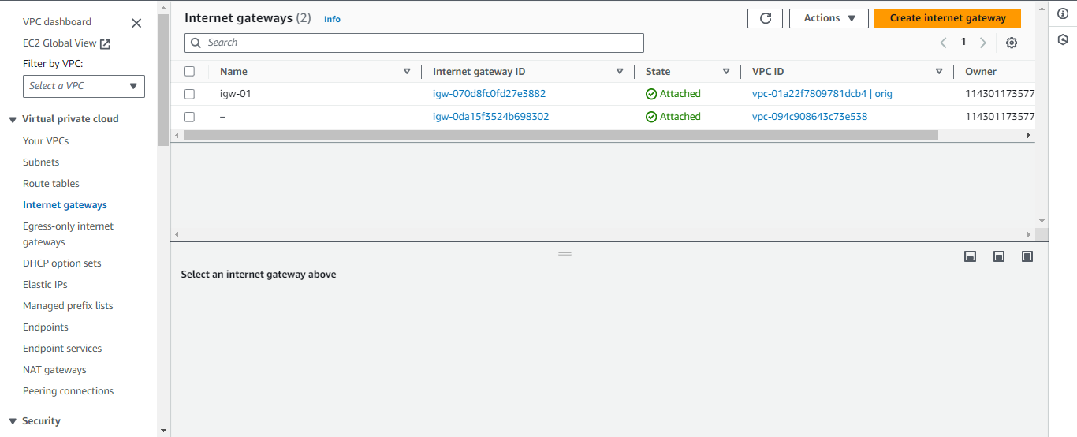

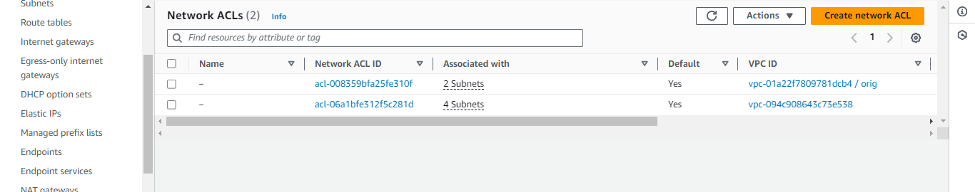

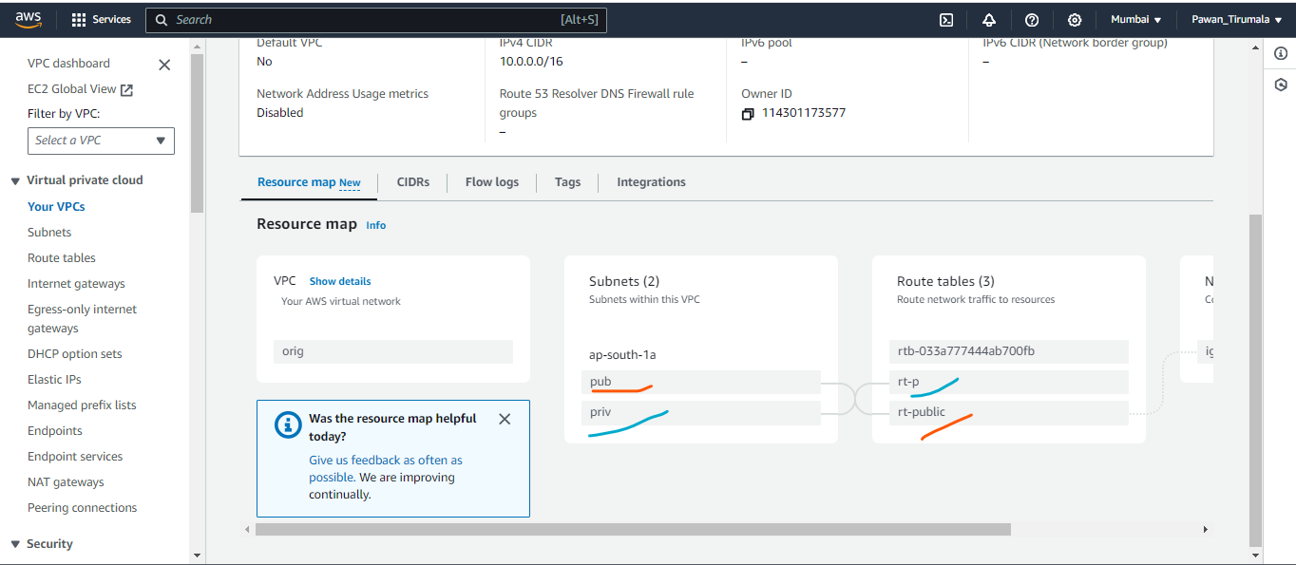

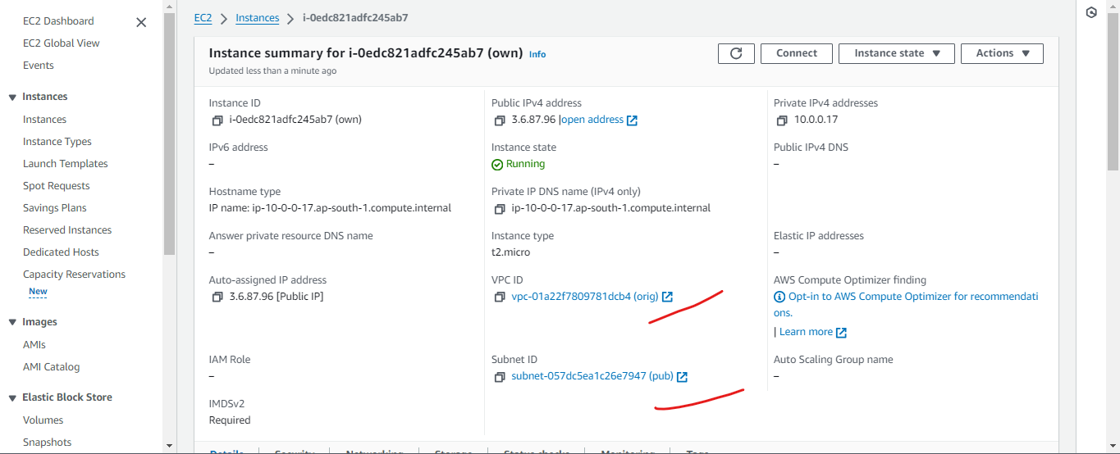

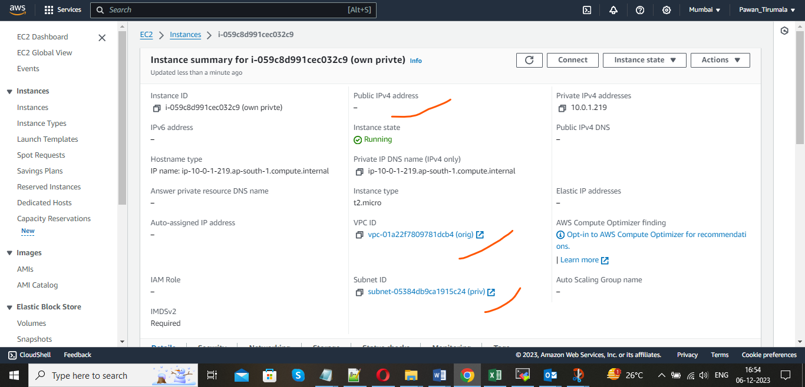

b. Connect these two Ec2 servers by using different connection methods u have learned. U can use AWS CLI or GUI method to complete this task.

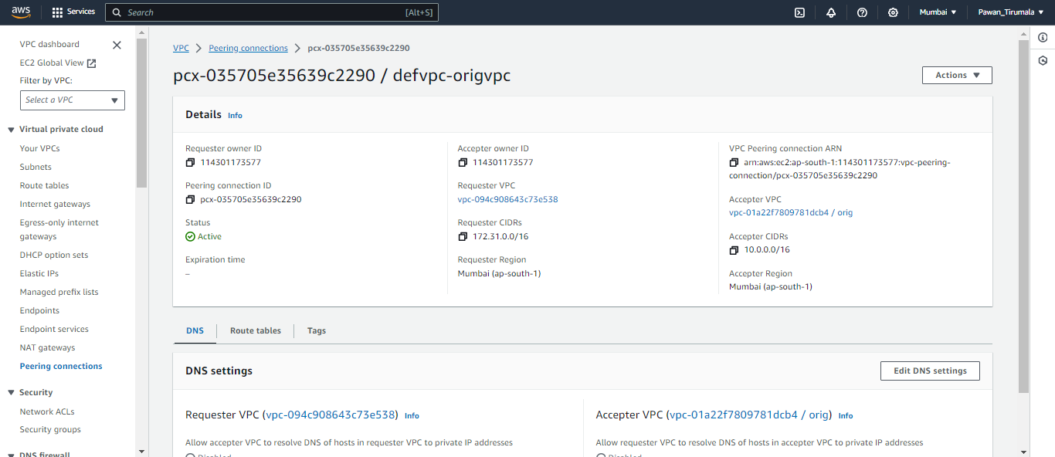

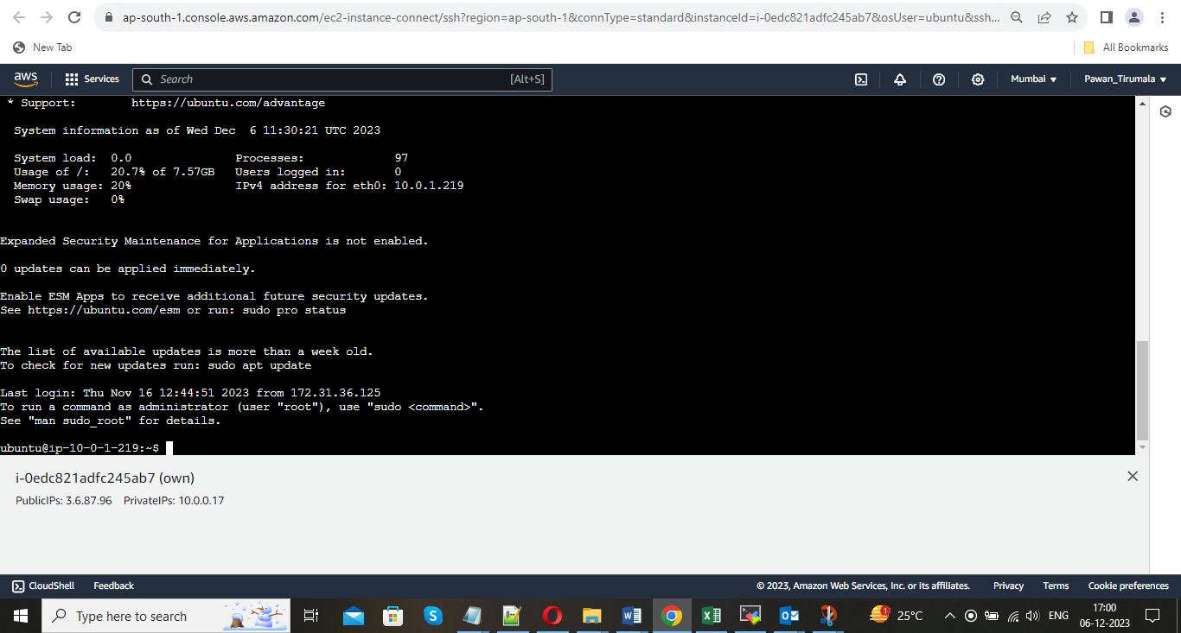

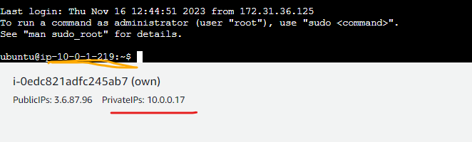

5.IAM policies & Roles

a. Create a Ec2 server and deploy an web application on top of it. For that attach an Iam role so that u can send the files

in Ec2 instance to s3 bucket.

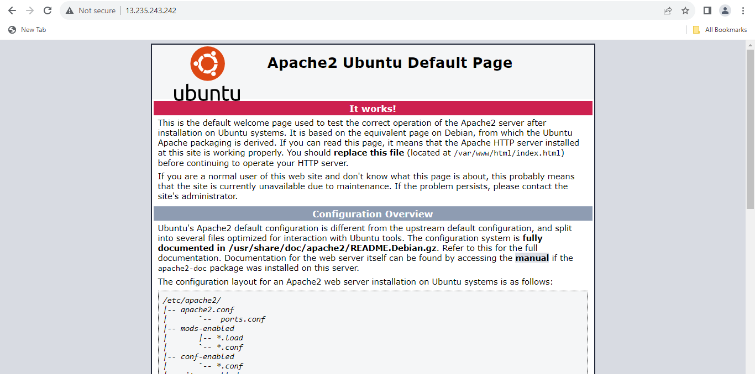

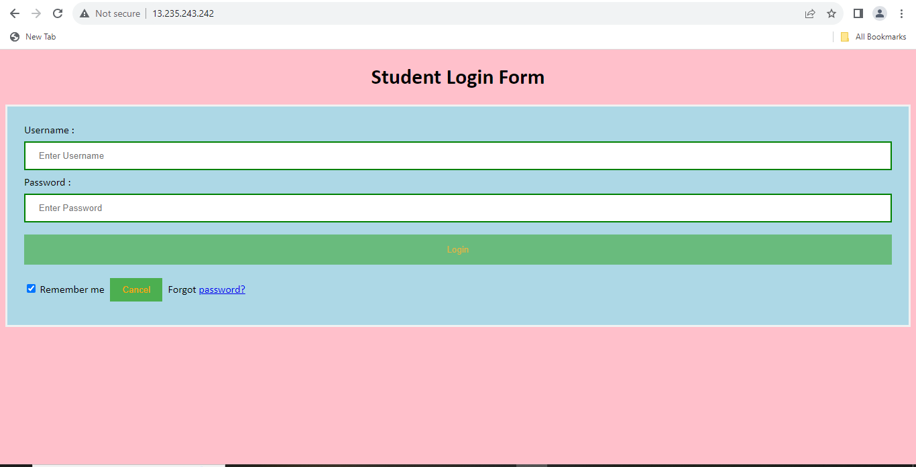

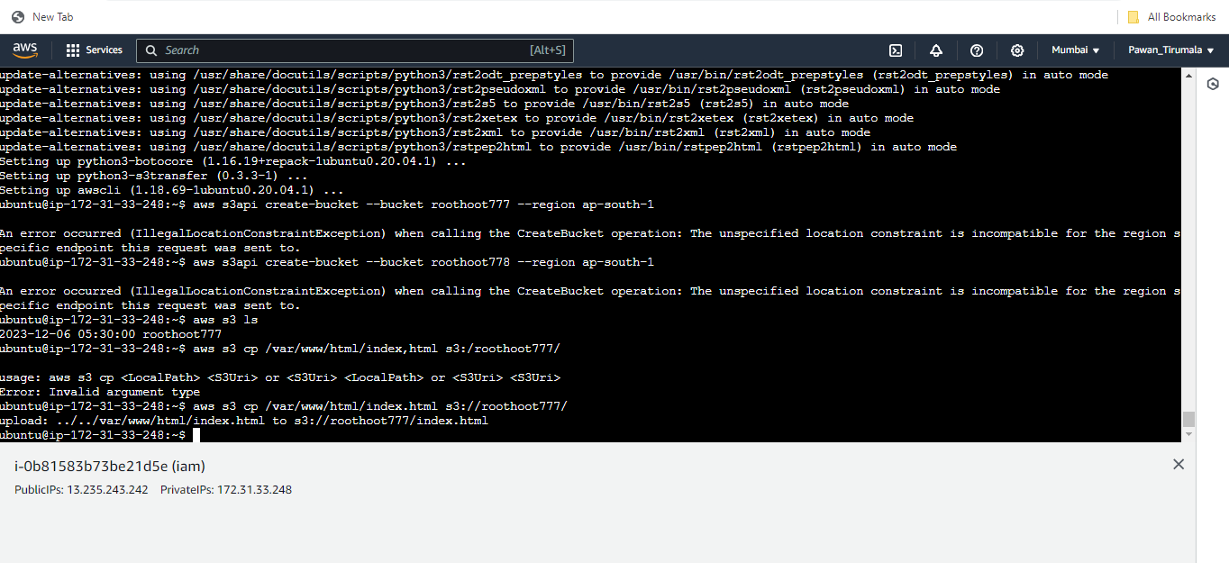



b. Send the application files to the s3 bucket by using above role . And start web application from s3 bucket also.

